PRESS RELEASE
AI-Driven optimization of the circular economy with plastics – invitation to participate in the KISS innovation project
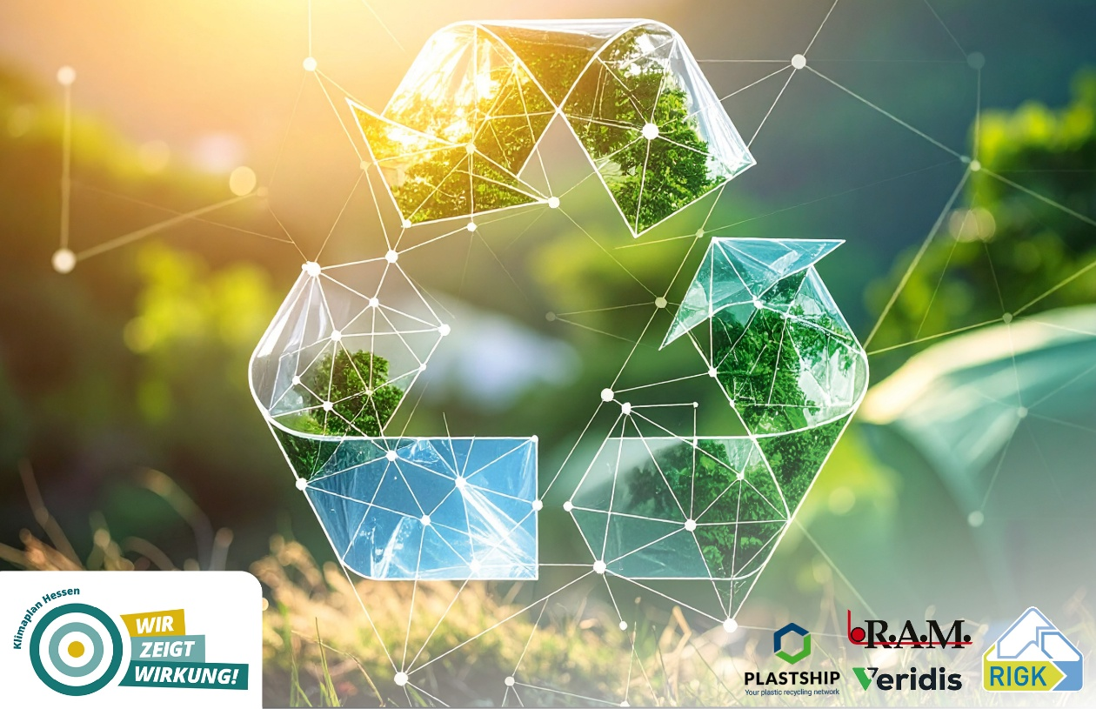
The aim of the planned AI-driven KISS platform is to identify the optimal recycling route for used plastics through advanced analysis and classification. © RIGK
Wiesbaden, June 2025 – The innovation project KISS („KI-basierte Qualifizierung, Steuerung und Optimierung von Stoffströmen zur Schließung von regionalen Ressourcenkreisläufen“ – "AI-Based Qualification, Management, and Optimization of Material Flows to Close Regional Resource Cycles") aims to return plastics to the circular economy in a sustainable and economically viable way. Initiated by RIGK, in collaboration with plastship, RAM and Veridis Technologies, and supported by Technologieland Hessen, the project is developing an AI-powered platform to analyse, classify and identify optimal recycling routes for used plastics. The focus is on high-quality applications such as films and packaging.
Beyond Germany and Hesse, KISS also stands for intelligent resource management on an international level. Interpreted as “Keep It Short & Simple,” KISS reflects what the plastics industry needs today – simple, efficient pathways to a better circular economy.
The industry is invited to actively participate in shaping KISS and the future of the circular economy. Opportunities include providing material samples for analysis and testing, contributing to new approaches for optimising material flows, and gaining early access to insights and technologies related to recycled materials – with the added benefit of learning more about the quality and characteristics of their own materials.
Innovations for the material use of tomorrow
The data and insights generated will specifically support the production and processing of recycled plastics, with the aim of sustainably improving availability, quality and application potential. In doing so, the project helps unlock new raw material potentials, optimise processes and reduce the carbon footprint along the entire value chain – originating directly from Germany and Europe.
Further information about KISS, the project partners and participation opportunities is available on the plastship website in the material quality section.

Further information:  RIGK GmbH  Anne Biel (Business Development Manager)  Friedrichstr. 6  65185 Wiesbaden (Germany)  Phone: +49 (0) 6 11/ 30 86 00-56  biel@rigk.de; www.rigk.de/en/  plastship GmbH  Andreas Bastian (Managing Director)  Auf der Lind 10  65529 Waldems (Germany)  Phone: +49 (0) 6126 58 980-12  bastian@plastship.com; plastship.com | Editorial contact / specimen copies:  Konsens PR GmbH & Co. KG  Dr.-Ing. Jörg Wolters  Hans-Böckler-Straße 20  63811 Stockstadt (Germany)  Phone: +49 (0) 60 27/99005-13  mail@konsens.de; www.konsens.de
This press release, along with images in print-ready resolution, is available for download at: www.rigk.de/en/knowledge/press

