PRESS RELEASE
ERDE agricultural film collection:
The rapidly growing importance of the material cycle
Wiesbaden, September 2018 – The number of manufacturers and importers involved in the ERDE Recycling initiative continues to grow, and more and more farmers and agricultural contractors are also using an ever-increasing number of collection points and direct collections to feed used agricultural films into environmentally-friendly recovery and recycling systems. A new video now shows how simple ERDE is and which steps follow collection to complete the material cycle.
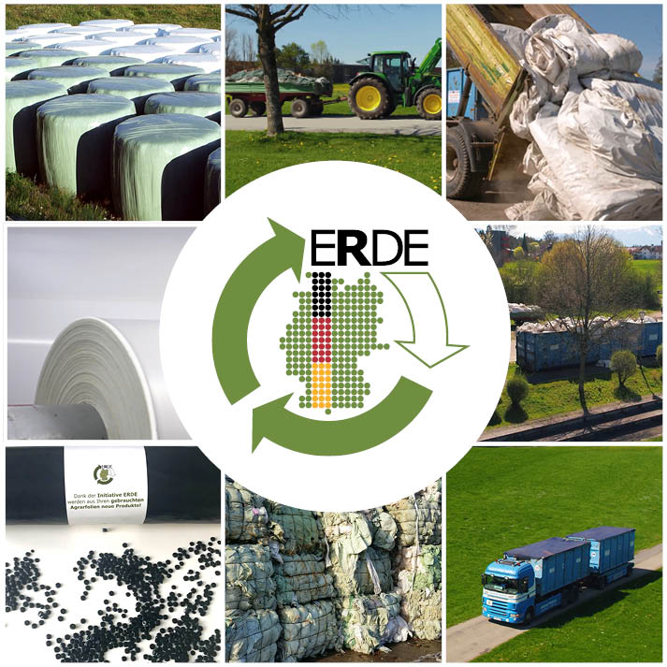 | Fig. 1. Environmentally-aware farmers and agricultural contractors use the ERDE service and transport their used, roughly cleaned agricultural films to the collection points offered all over Germany. A recently finished video shows how ERDE works and how the process continues. The films collected are pressed into bales in waste disposal plants, before recycling companies process them into granules that can be made into new products in a sustainable way.  All images: © RIGK
ERDE Recycling (http://www.erde-recycling.de) – the solution for environmentally-friendly recovery and recycling of used agricultural films supported by environmentally-aware film manufacturers and importers, the IK Industrievereinigung Kunststoffverpackungen e. V. and RIGK – offers farmers and agricultural contractors opportunities to hand in their used agricultural plastics nationwide once again in 2018. Despite the difficult situation faced by the waste disposal market and the insufficient recycling capacity in Europe, the ERDE service continues to offer film users a reliable and low-cost delivery option, which they are increasingly using.
As the quantity collected has augmented, so has the number of collection points. By the end of 2018, ERDE will have offered well over 400 collection dates, as well as countless mobile collections direct from farmers. This pleasing development, which is very beneficial to the environment, is in part thanks to the involvement of two further film manufacturers who have joined the ERDE service this year: Aspla - Plásticos Españoles S.A and Sotrafa S.A.
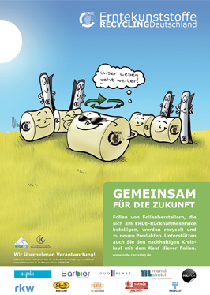 | Fig. 2. Ten manufacturers are currently involved in ERDE. As well as the two new members Aspla - Plásticos Españoles S.A and Sotrafa S.A., they are Groupe Barbier, Duo-Plast AG, Manuli Stretch Deutschland GmbH, POLIFILM EXTRUSION GmbH, RKW Agri GmbH & Co KG, Ab Rani Plast Oy, RPC BPI GROUP and TRIOPLAST GmbH.
Christian Schröder, member of the Executive Board of the voluntary ERDE initiative, says: “Being involved in ERDE is a reliable, efficient and cost-effective way to achieve sustainable handling of plastic films used in agriculture across the country. We are working hard to get the last few manufacturers, distributors and importers on board. Needless to say, we would like all relevant companies to join in quickly and commit to taking responsibility for their products even after use. The closer we get to this goal, the more films we can turn back into raw materials through our orderly, responsible disposal. That is why we are so delighted to welcome our new members. After all, they are living proof that our approach to a sustainable cycle is being met with approval. I would like to expressly encourage all companies who have not yet joined our initiative to take a close look at their commitment to the environment and their responsibility for their products.”
Christer Vidjeskog, Sales Manager at Ab Rani Plast Oy, endorses the continuation of this successful approach: “We expect our work and the positive feedback from the farmers to convince more companies to get involved in 2019, especially given the current situation in recycling. On this basis, we have set ourselves some tough goals for the year ahead. They include giving farmers even more opportunities to hand in their films, thus increasing the return quantities in the initiative even further.”
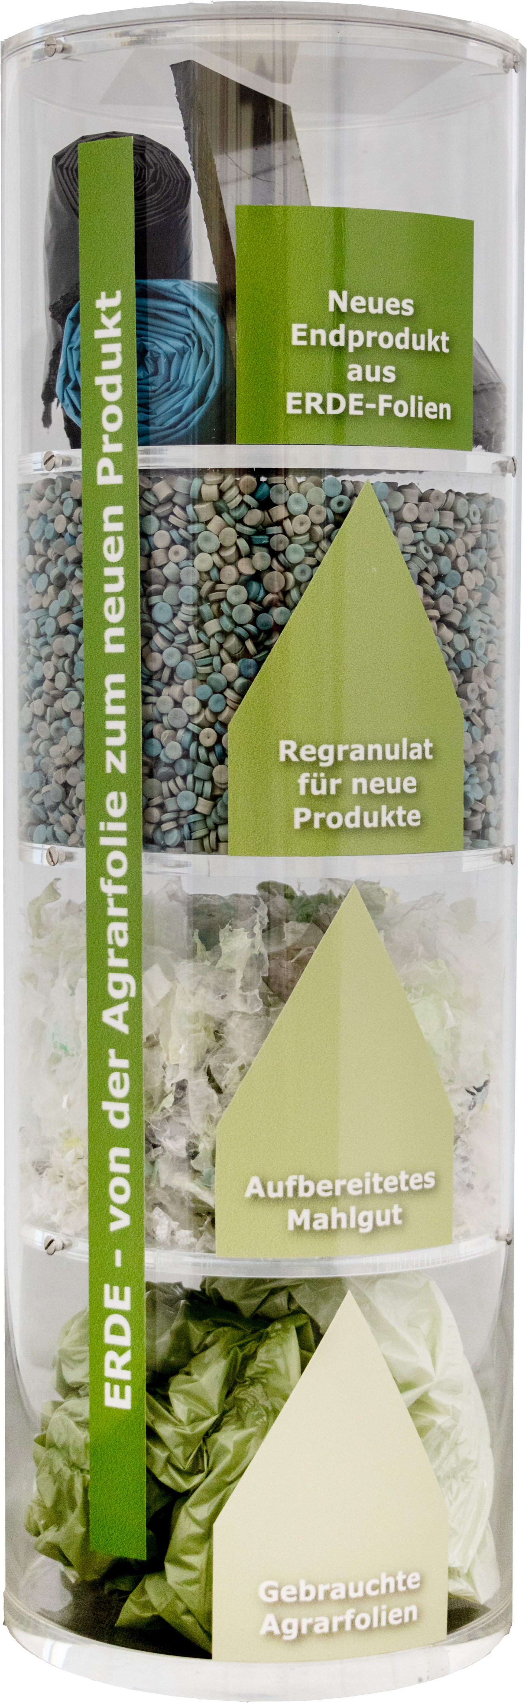 | Fig. 3. From agricultural film waste to new film – the ERDE Recycling initiative paves the way by ensuring that used agricultural films are recovered and recycled in an environmentally-friendly way.
ERDE will use the DeLuTa on December 5 and 6, 2018 in Bremen to present the concept to a trade audience at RIGK’s stand in Hall 6. There, ERDE will demonstrate to farmers and agricultural contractors just how simple, cost-effective and convenient it is to dispose of agricultural films using this manufacturer-sponsored initiative for the environmentally-friendly handling of used plastics. This is also the aim of a new video, only recently completed, that shows how the material cycle enabled by the ERDE service complements the natural cycles of nature. Authentic statements from farmers who think and act sustainably underline not only the conviction with which they use ERDE, but also how happy they are with the way the processes are organised. The new video can be accessed at www.erde-recycling.de/en/about-erde/what-is-erde.html
About ERDE
Under the umbrella of IK Industrievereinigung Kunststoffverpackungen e.V. and in cooperation with RIGK as the system partner, ERDE organises the recovery and eco-efficient material recycling of separated used agricultural films made from PE-LD (fraction 1) and PE-LLD (fraction 2) via collection partners across Germany. Agricultural contractors and farmers collect the crop plastics and hand them in to a collection point swept-clean and free from coarse contamination (www.erde-recycling.de/rund-um-die-abgabe/sammelstellen-termine.html). The price is determined directly at the point of collection. Recycling companies then process the collected materials into new plastic raw materials. The members of ERDE are ASPLA - Plásticos Españoles S.A. (www.aspla.com), Groupe Barbier (www.barbiergroup.com), Duo-Plast AG (www.duoplast.ag), Manuli Stretch Deutschland GmbH (www.manulistretch.com), POLIFILM EXTRUSION GmbH (www.polifilm.de), RKW Agri GmbH & Co KG (www.de.rkw-group.com), Ab Rani Plast Oy (www.raniplast.com), RPC BPI GROUP (www.rpc-bpi.com), Sotrafa S.A. (www.sotrafa.com) and TRIOPLAST GmbH (www.trioplast.de).

More information:  RIGK GmbH  Claudia Hoese  Marketing and Customer Support  Friedrichstr. 6, D-65185 Wiesbaden  Tel.: +49 (0) 6 11/ 30 86 00-12, Fax: -30  hoese@rigk.de; www.rigk.de | Editorial content, voucher copies:  Konsens PR GmbH & Co. KG  Dr Jörg Wolters  Hans-Kudlich-Straße 25  D-64823 Groß-Umstadt  Tel.: +49 (0) 60 78/93 63-0, Fax: -20  mail@konsens.de; www.konsens.de
You can find this press information as a doc file and the images in a printable resolution for download at www.rigk.de/wissenswert/presse

