Press release
European plastics group encourage innovation and sustainability
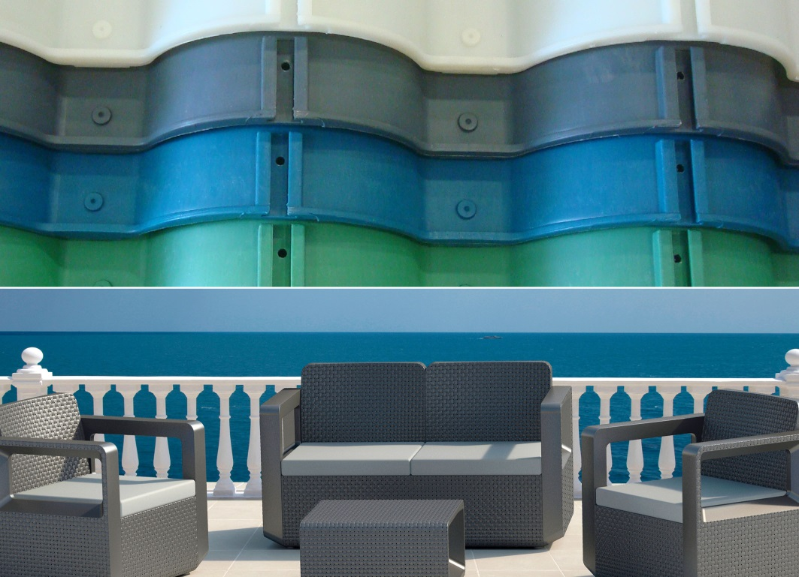
On the occasion of the 2017 competition, EPRO awarded prizes in two categories. In the "Products" area, the plastic tiles of the Spanish manufacturer Roofeco System (above) won. The award in the Design category also went to Spain: Sp-Berner received it for a terrace furniture series (below).
Wiesbaden, Dezember 2018 – The European Association of Plastics Recycling & Recovery Organisations (www.EPRO-plasticsrecycling.org) is inviting companies across Europe to enter their products for the EPRO Best Recycled Plastic Product Innovation and Sustainability Awards. The aim of this competition is to raise awareness and showcase the latest product innovations for recycled plastics in a growing variety of products and items. The awards also recognise the progression in the applications of recycled plastics and represents a real opportunity for the industry to further demonstrate commitment to the environment and saving resources through use of recycled materials.
Entry is now open at bestproduct.epro-plasticsrecycling.org and can enter either the Innovation Award or Sustainability Award.
Stuart Foster, CEO of RECOUP, said “raising awareness of the products made from recycled plastics helps stimulate demand and appetite for the design and manufacture more products made from recycled plastic and to encourage new entrants into the market place. We recognise the importance of awards such as this to inform and educate the public of advances currently being made in this arena.”
Entries to the competition close on 18th January 2019. There is no cost to enter. Winners will be announced at Identi-plast 2019, due to take place in London 7th and 8th March 2019. The competition enables companies to further demonstrate their commitment and work in the area of Corporate Social Responsibility, and for the consumer to more fully understand the scope of their environmentally friendly actions.
Peter Sundt, Secretary General of EPRO said, “It is important that consumers and industry see the development in the recycling of plastics. We see this award as being a vehicle to showcase the innovation within plastics recycling and the many products that are currently being manufactured across Europe”.
The competition is held biannually, the 2017 product winners were Roofeco Systems, from Spain, for their Spanish Roof Tiles. The winning product demonstrated the advantages in terms of environmental benefits of using recycled plastics as opposed to the traditional methods of manufacturing rooftiles. Roofeco had used technology to overcome previous restrictions of plastics use for this type of product and proved that there were considerable environmental savings over the life-time of the tiles in contrast to other materials. Proving the use of recycled plastics in this design were ecologically sound with long term viability.
The European Association of Plastics Recycling & Recovery Organisations (www.EPRO-plasticsrecycling.org)
is a pan-European partnership of specialist organisations that are working to develop and deliver efficient solutions for the sustainable management of plastics resources, now and for the future.
The EPRO platform allows members to optimise national effectiveness of collection, handling and reprocessing of plastics through international co-operation. By studying successful approaches, sharing knowledge, evaluating different solutions and examining obstacles to progress. By working together EPRO members can identify common barriers and issues that can be overcome to increase efficient plastics recycling and recovery.

Each EPRO member is working to meet and exceed requirements set by EU and national packaging directives, and committed to:
- exchange and publish information and experiences
- develop improved strategies for prevention, recycling and recovery of plastics packaging waste with regard to the EU thematic strategy on waste and recycling
- support technological projects designed to improve the efficiency and cost-effectiveness of plastics recycling and recovery throughout Europe
- evaluate new technologies and to stimulate improved quality and value of used plastics on a scientific basis.
There are 19 EPRO member organisations including 14 European countries plus South Africa and Canada.
As a certified specialist company for trademark users (fillers, distributors, traders and importers), RIGK GmbH, founded in 1992, organises the recovery of used, empty packaging and plastics from its German customers and arranges the safe and sustainable recycling of them. In addition, the company provides advice on the development of individual recovery and recycling solutions. On an international level, RIGK is represented in Romania and Chile. The Romanian subsidiary (www.rigk.ro) also undertakes the recovery and recycling of used packaging and plastics there. RIGK Chile SpA advises local industry in establishing their systems and complying with legal environmental and recycling constraints. The shareholders of RIGK GmbH are well-known manufacturers of plastics and packaging. RIGK GmbH has been a member of EPRO since 2006, where it established the working group for the recycling of agricultural plastics waste. Together with EPRO RIGK will organize the 3rd international Recyclingforum Wiesbaden in November 2019.
Further information:
RIGK GmbH
Claudia Hoese
Marketing und Kundenbetreuung
Friedrichstr. 6, D-65185 Wiesbaden
Tel.: +49 (0) 6 11/ 30 86 00-12, Fax: -30
hoese@rigk.de; www.rigk.de

RECycling Of Used Plastics Limited
Anne Hitch
Tel.: +44 (0) 1733 375676
anne.hitch@recoup.org

