PRESS RELEASE

RIGK helps Chile achieve an effective circular economy

German disposal specialist enjoys huge success in sensitising Chilean farmers to recycling used agricultural plastics, with 35 tonnes of plastic waste for sustainable recycling in the first collection alone.

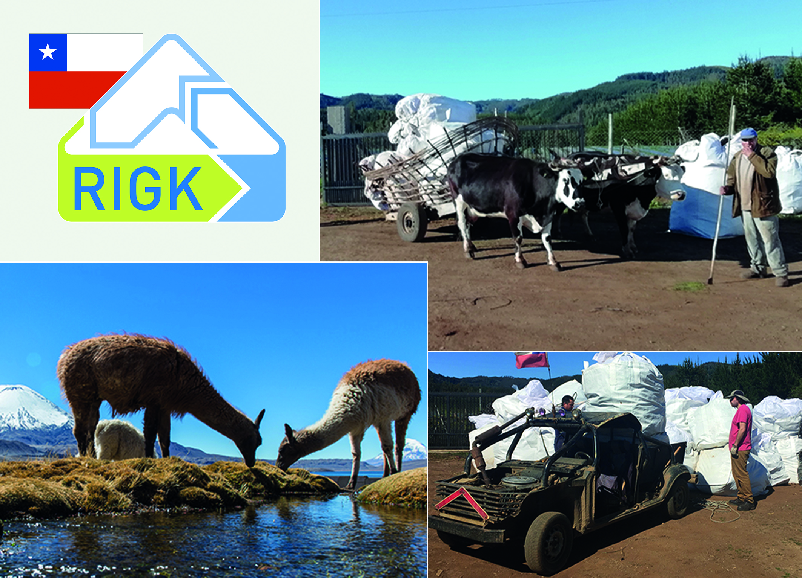

Santiago de Chile, January 2019. Around 550 farmers from the Maule region of central Chile have now joined a pilot project in the Good Agricultural Practices (GAP) campaign, organised by the Chilean Environmental Authority with support from the German disposal specialist RIGK and the environmental consultancy firm WSP. In a series of twenty workshops, the farmers received training on the management of plastic waste, before taking part in the first large recovery campaign. 35 tonnes of used mulch film, worn out irrigation hoses and empty agricultural pesticide containers were recycled or disposed of at approved disposal sites. Before this, more than half the farmers had simply burned or buried their plastic waste, making a significant contribution to the country’s environmental problems.

Chile looks to German environmental expertise
With the GAP campaign, the Chilean Environmental Authority hopes to establish an effective circular economy in the country. To do this, it is looking to international expertise and the 25 years of experience of the German disposal specialist RIGK, who has been involved with a 100% subsidiary in Chile since 2016. The collaboration focuses on developing an effective waste management system that also works in remote regions such as Maule, which is dominated by small farms. The Chilean population has shown little awareness for environmental issues in the past. A targeted campaign of sensitisation aims to change that. “Information and training for local farmers will be crucial to the success of the campaign. After all, they – the system’s users – will only take part in collection campaigns if they understand the added value,” explains Jan Bauer, Managing Director of RIGK Chile. “The success of the pilot project proves that we are on the right track. If the system works in one of the country’s most remote regions, with a few small tweaks it can work anywhere.”

Pablo Sepúlveda, Head of the Environmental Authority for the Maule region, believes that the pilot project heralds the start of greater environmental awareness for sustainability among the population. “The Ministry for the Environment is supporting the campaign in order to reduce the plastic waste we produce every day. After all, many agricultural plastics end up contaminating our fields, rivers and oceans. The project supports us in our goal of installing sustainable waste management models. It is not the end, but the beginning of a phase in which we are finding more and more concrete and effective solutions for our environmental problems.”

From now on, the Chilean Environmental Authority plans to conduct regular collections of agricultural plastic waste. The pilot project will also be rolled out to other regions in Chile.

Founded in 1992, RIGK GmbH (www.rigk.de) is a certified specialist company for trademark users (fillers, marketers, dealers and importers) that organises the recovery of used, empty packaging and plastics from its German companies for safe and sustainable recycling. The company also provides support in the development of tailored recovery and recycling solutions. RIGK is represented internationally with subsidiaries in Romania and Chile. Shareholders in RIGK GmbH include renowned producers of plastics and packaging materials. Since 2006, RIGK GmbH has been a member of EPRO, where it founded the working group for recycling plastic waste from agriculture.
More information:  RIGK GmbH  Claudia Hoese  Marketing and Customer Support  Friedrichstr. 6, D-65185 Wiesbaden  Tel.: +49 (0) 6 11/ 30 86 00-12, Fax: -30  hoese@rigk.de; www.rigk.de | Editorial content, voucher copies:  Konsens PR GmbH & Co. KG  Dr Jörg Wolters  Hans-Kudlich-Straße 25  D-64823 Groß-Umstadt  Tel.: +49 (0) 60 78/93 63-0, Fax: -20  mail@konsens.de; www.konsens.de

