PRESS RELEASE
Invitation from RIGK and EPRO to the 3rd International Recycling Forum
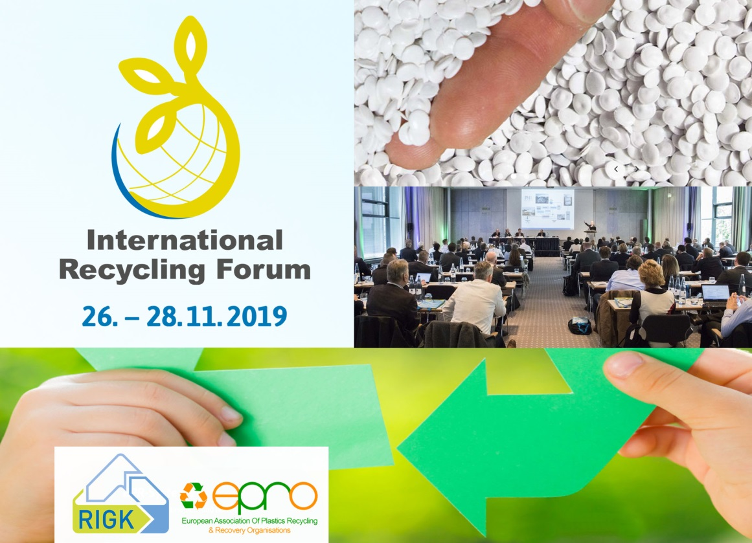
Wiesbaden, Germany, September 2019 – RIGK GmbH and the European Association of Plastics Recycling & Recovery Organisations (EPRO) are issuing an invitation to the 3rd International Recycling Forum which will run from 26th to 28th November 2019 in Wiesbaden, Germany. The event will focus on trends and strategies relating to the application of circular economy principles to plastics. Some thirty papers and presentations will cover topics ranging from design for recycling via innovative recycling technologies and extended producer responsibility (EPR) to making efficient use of recycled materials. The emphasis of the second day of the forum will be on the collection and recycling of agricultural plastics. An accompanying exhibition will provide further information about the sector. The language of the conference is English.
The welcome session will address overarching topics such as the principles and challenges of plastics recycling and an analysis of the material flows of plastics in Europe. The second block will then include reports about the use of recycled materials in Fast-Moving Consumer Goods (FMCG) and in stretch films. Another paper will describe the use of digital business models for closing the recyclable resource loop. One of the main themes of the afternoon will be the current status of the post-consumer plastics packaging value chain in Germany, complemented by an examination of the prospects for potential recycling revenue from the application of optimized recycling planning and new recycling technologies. After papers on chemical recycling, the first day will conclude with presentations on the current state of the art in the production of high-quality recycled pellets, the separation of different plastics fractions and mulch film recycling.
The second day of the forum will include reports on international projects and their specific objectives and the successes achieved in agricultural plastics recycling. Topics include a Spanish initiative in the fruit and vegetables sector and options for boosting efficiency by optimizing information management for all the procedures involved in EPR systems. The day will conclude with status reports on projects in the USA, Chile, New Zealand, Germany, Russia and Italy.
As Jan Bauer, RIGK, says: "Plastics are today facing unprecedented levels of public criticism. However, the use of plastics will continue to increase globally because they help to save energy and resources and they make vital contributions to supplying the world's population with food and to climate protection. Ensuring efficient collection and recycling of plastic waste is one of the solutions to this dilemma. The 3rd International Recycling Forum will bring together the major players who can help make this solution a reality in order to exchange opinions, ideas and experience. Our aim is to provide every participant with much food for thought for their ongoing activities which will help them to solve the very specific problems they face in relation to the use, collection and recycling of plastic waste."
Attendance will cost EUR 696 including the evening event at the local Johannisberg Castle winery (incl. VAT). The conference venue is the Dorint Pallas hotel in Wiesbaden. The registration form and further information, list of exhibitors and conference program can be found at www.international-recycling-forum.de/en. Your contact is Mareike di Leo (dileo@rigk.de, +49 611 308600-10).
As a certified specialist company, RIGK GmbH (www.rigk.de) organizes, on behalf of its licensees (fillers, distributors, traders and importers), the recovery of used, empty packaging and plastics from its German customers and arranges the safe and sustainable recycling of these materials. In addition, the company provides advice on the development of individual recovery and recycling solutions. Internationally, RIGK is represented in Romania and Chile. RIGK's Romanian subsidiary (https://www.rigk.de/ueber-rigk/rigk-weltweit/internationale-beratung-projektarbeit/rigk-romania/) similarly recovers and recycles used packaging and plastics in Romania. RIGK Chile SpA (https://www.rigk.de/ueber-rigk/rigk-weltweit/internationale-beratung-projektarbeit/rigk-chile/) advises local industry on establishing systems and implementing statutory environmental and recycling requirements. The shareholders of RIGK GmbH are well-known manufacturers of plastics and packaging. RIGK GmbH has been a member of EPRO since 2006, where it established the working group for the recycling of agricultural plastics waste. RIGK is the joint organizer with EPRO of the International Recycling Forum in Wiesbaden which will take place for the third time in 2019.
EPRO, the European Association of Plastics Recycling and Recovery Organisations, is a pan-European partnership of 23 specialist organizations that are working to develop efficient solutions for the sustainable management of plastics resources.
Further information:  RIGK GmbH  Claudia Hoese  Marketing and customer support  Friedrichstr. 6, D-65185 Wiesbaden  Tel.: +49 (0) 6 11/ 30 86 00-12, Fax: -30  hoese@rigk.de; www.rigk.de | Editorial contact and voucher copies:  Konsens PR GmbH & Co. KG  Dr. Jörg Wolters  Hans-Kudlich-Straße 25  D-64823 Groß-Umstadt  Tel.: +49 (0) 60 78/93 63-0, Fax: -20  mail@konsens.de; www.konsens.de

Press releases from RIGK and related images in print-ready resolution can be downloaded from http://www.rigk.de/en/worth-knowing/press/

