PAMIRA® delivers good ﬁgures despite extreme weather conditions and a downward trend in the overall market
Founded in 1996, PAMIRA® (Packmittel Rücknahme Agrar = ‘agricultural packaging recovery) is a recovery and disposal system for clean (empty of usable product) packaging for crop protection agents and liquid fertilisers used in the commercial agricultural sector. While the company was unable to match the record results of 2017 in its ﬁgures for 2018, PAMIRA® nonetheless achieved a ﬁgure of 2,836.73 tonnes for the twenty-second year since its forma- tion, despite facing some particularly severe weather conditions and a negative trend in the overall market. The volume recorded represents a recovery quota of 76.9%.
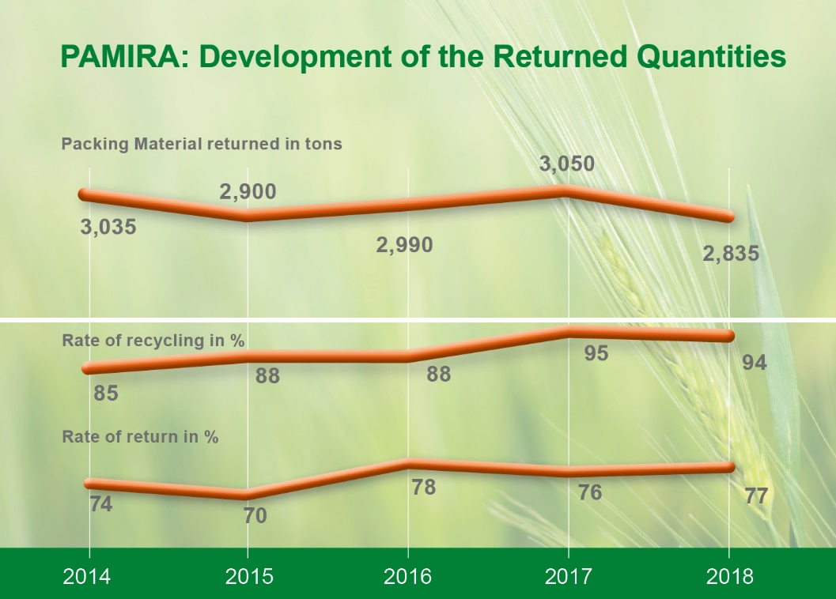

PAMIRA® Rate of return and recycling during the last 5 years © PAMIRA

The stable results of recent years clearly demonstrate that PAMIRA® is now established and recognised as a key piece of the puzzle in achieving “good agricultural practice”. Over the years, a thriving and trusted partnership has developed between agricultural businesses and agricultural chemical dealers/manufacturers participating in the system – and continues to grow to this day.
In the reporting year, PAMIRA® offered 365 ofﬁcial collection points and 388 collection dates. Around 170 pre-collections made by agricultural businesses and dealers were reported using the form from Wiesbaden based RIGK GmbH (which operates the PAMIRA®-SYSTEM), and integrated into the ofﬁcial PAMIRA® collection schedule without any issues. Trained inspectors were on hand at all times to ensure that the PAMIRA® acceptance criteria were met in full. The packaging delivered will always be rejected if it is still dirty or does not bear the PAMIRA® licence mark. Agricultural businesses who dispose of packaging with PAMIRA® are issued with a conﬁrmation of the proper disposal of their packaging. This is a real beneﬁt as it counts as an ofﬁcial record pursuant to the German Commercial Waste Act.

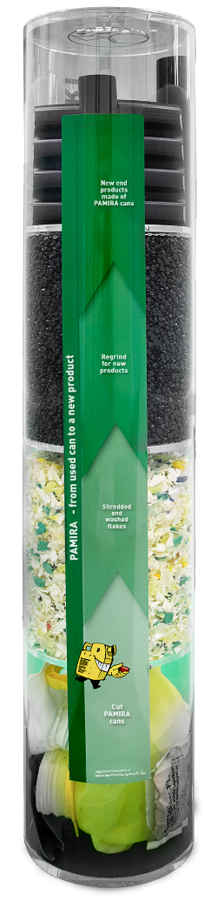
In 2018, the proportion of packaging waste collected sent for mechanical recycling was once again impressive, at over 90 percent. To provide agricultural businesses with a visible reminder of this successful circular economy, recycling pillars have been set up at collection points since 2018 and have been very well-received.
In 2019, PAMIRA® will achieve another milestone in making the circular economy a reality with the use of collection bags that are manufactured from 85% recycled agricultural plastic ﬁlms. These are sourced from the recovery system ‘ERDE’ (www.erde-recycling.de), which is also run by RIGK. PAMIRA® will also be devoting more time and energy to chemical recycling methods.

Contact:
Thorsten Heil, System Manager PAMIRA
Tel.: +49 (0) 6 11/ 30 86 00-17
heil@rigk.de
www.pamira.de

