Report from the 3rd International Recycling Forum, 26 to 28.11.2019, Wiesbaden:
Cooperation is the only option in the circular economy
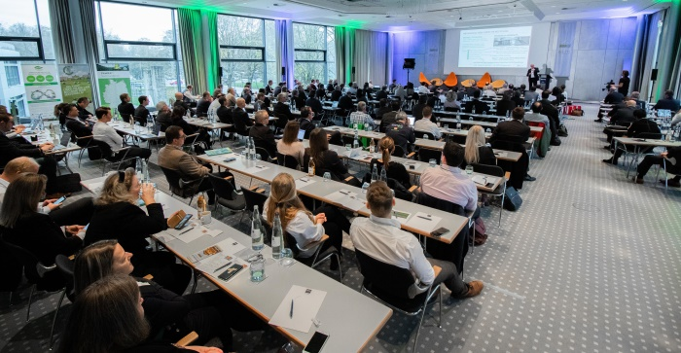 | 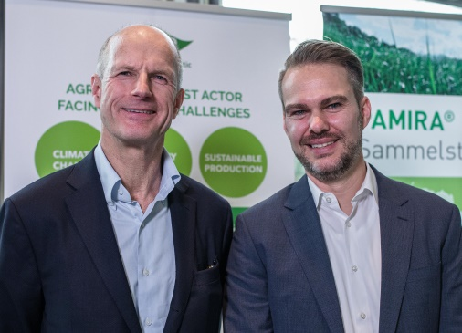
Some 150 delegates from 22 countries responded to the invitation to Wiesbaden where they experienced two very informative days. (Photo: RIGK) | EPRO General Secretary Peter Sundt (left) and Jan Bauer, authorised representative of RIGK, were delighted with the event. (Photo: RIGK)
Wiesbaden, December 2019 - Peter Sundt, General Secretary of EPRO, the European Association of Plastics Recycling & Recovery Organisations, sums it up when he says that he sees international cooperation as being key to the success of recycling. "Dialogue within the sector is vital. This event is a demonstration of optimistic, innovative thinking, which is just what we need if we are to close the raw materials loop in Europe and indeed worldwide. Countries such as Canada, New Zealand and South Africa are already part of our network and are using our tried and trusted methods. Environmental protection has both global and local aspects. It's not enough to clean up beaches or collect rubbish from our streets. When it comes to the circular economy, we are all of us responsible for the whole world."
RIGK had jointly organised the symposium with its accompanying exhibition from 26 to 28 November 2019 in Wiesbaden with the European Association of Plastics Recycling & Recovery Organisations (EPRO). Around 150 delegates from 22 countries took the opportunity to catch up with experience and developments in plastics recycling at an international level and to cultivate their networks.
"We address the hot topics in the sector", explains Jan Bauer, authorised representative of RIGK GmbH. Following an introduction outlining the status of the circular economy, the second block of papers focused on design for recycling and the use of recycled materials. New machinery and innovations in chemical recycling were also introduced. International agricultural plastics collection and recycling projects, for instance in Spain, Italy, Chile, Ireland or New Zealand, were presented in the fourth block.
As Jan Bauer knows: "A properly functioning circular economy means that recycled materials have to be used in high-quality applications and this entails recycling-friendly product design and consumer acceptance. Only if we manage to keep recycled materials within the loop will the business model succeed."
Andreas Malmberg, CEO Triplast Group, showed how to make a success of closed-loop recycling of PE films and described where the challenges lie. "By 2025, 50% of the plastics used in the EU will have to be recycled and put to renewed use as materials. This is a challenge to processors because the higher a product's recycled material content, the more complex the processing becomes, so reject rates rise."
A recurrent theme at the Forum was how important product design is to comprehensive recycling. As Andreas Bastian, co-founder of the startup Plastship, points out "… ultimately waste is only a result of poor design".
Ton Emans, president of Plastics Recyclers Europe (PRE), summed up how this series of events has developed: "The first two editions of the Recycling Forum mainly focused on recycling. But now we are taking a wider view and addressing the circular economy. The new rules have already had an impact on the business. In the past, plastics products were recycled at the end of their life cycle and then applications were sought for the material. In the future, it can be assumed that recyclates will be mandatory for many products. In this sense, producers of agricultural films have voluntarily committed themselves to collecting and recycling, although, at just 3%, agriculture accounts for only a relatively small proportion of overall plastics consumption."
Emans advises taking a holistic approach: "We need to examine the entire chain from production through use and disposal to remanufacture and use for new products. The sector has in recent years been championing the idea of sustainability but now the time has come to put circular economy concepts into practice. The EU has understood this and taken the first steps with its Plastics Strategy. The intention is for a product to be recyclable after use so that new high-quality products can be produced from it."
Clemens Kitzberger, Post Consumer Recycling Business Development Manager at Erema, emphasised that the event was bringing together representatives from the entire value chain. "This is very important because ever closer cooperation between stakeholders is what is needed now."
Peter Sundt is calling on the associations to do their part in developing circularity and to seize the opportunities it presents. "The EU has given us one last chance. The good news here is that Brussels does indeed see the potential the plastics industry holds. Recycling is all of our business. So we, EPRO, have an obligation to society as a whole."
As a certified specialist company for trademark users (fillers, distributors, traders and importers), RIGK GmbH, founded in 1992, organises the recovery of used, empty packaging and plastics from its German customers and arranges the safe and sustainable recycling of them. In addition, the company provides advice on the development of individual recovery and recycling solutions. On an international level, RIGK is represented in Romania and Chile. RIGK's Romanian subsidiary (https://www .rigk.de/ueber-rigk/rigk-weltweit/internationale-beratung-projektarbeit/rigk-romania/ and www.rrigk.ro) similarly recovers and recycles used packaging and plastics in Romania. RIGK Chile SpA (https://www.rigk.de/ueber-rigk/rigk-weltweit/internationale-beratung-projektarbeit/rigk-chile/) and www.rigk.cl) advises local industry on establishing systems and implementing statutory environmental and recycling requirements. The shareholders of RIGK GmbH are well-known manufacturers of plastics and packaging. RIGK GmbH has been a member of EPRO since 2006, where it established the working group for the recycling of agricultural plastics waste.
EPRO, the European Association of Plastics Recycling and Recovery Organisations, is a pan-European partnership of 23 specialist organisations that are working to develop efficient solutions for the sustainable management of plastics waste.

Further information:  RIGK GmbH  Claudia Hoese  Marketing and customer support  Friedrichstr. 6, D-65185 Wiesbaden  Tel.: +49 (0) 6 11/ 30 86 00-12, Fax: -30  hoese@rigk.de; www.rigk.de | Editorial contact and voucher copies:  Konsens PR GmbH & Co. KG  Dr. Jörg Wolters  Hans-Kudlich-Straße 25  D-64823 Groß-Umstadt  Tel.: +49 (0) 60 78/93 63-0, Fax: -20  mail@konsens.de; www.konsens.de

This press release as a .docx file and the photo in print-ready resolution are available for download from: http://www.rigk.de/en/worth-knowing/press/

