European Commission plans amendment to the EU Packaging Directive
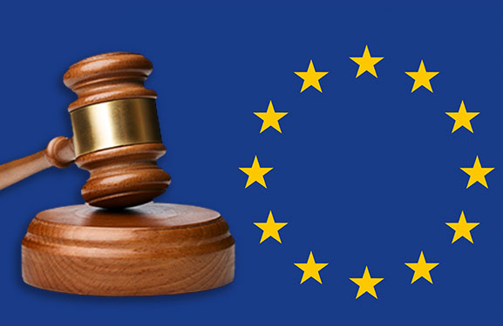
The European Commission is planning a further amendment to the EU Packaging Directive. This emerges from a roadmap published by the EU Commission on 11 June 2020 for a corresponding legislative project. The EU Packaging Directive was already amended in 2018, but now the EU Commission sees further need for adaptation in the context of the implementation of the European Green Deal, which aims to achieve a sustainable, climate-neutral EU economy and in this respect also includes an action plan for closed loop recycling management.
The amendment of the EU Packaging Directive is intended to provide the legal basis for all packaging put into circulation in the EU to be recyclable or reusable by 2030. In particular, the European Commission considers that the current regulations open up too much leeway for interpretation with regard to the recyclability of packaging. For example, a trend towards weight reduction at the expense of recyclability can be observed.
Against this background, the EU Packaging Directive is to be reviewed and revised, in particular with regard to the following points:
- Improving packaging design to promote reusability and recyclability
- Increasing the recyclable content in packaging
- Stringent reduction of excessive packaging
- Reducing packaging waste
The amendment of the EU Packaging Directive is intended to provide the legal basis for all packaging put into circulation in the EU to be recyclable or reusable by 2030.
The European Commission's roadmap provides for the following further steps: a so-called "impact assessment" of the proposed new regulations will be carried out later this year. Impact assessments are prepared for initiatives, such as legislative proposals, that are expected to have significant economic, social or environmental impacts. Finally, the EU Commission's amendment proposal is due to be presented in 2021.

The European Commission's roadmap for the amendment to the EU Packaging Directive and feedback on it can be found here: https://ec.europa.eu/info/law/better-regulation/have-your-say/initiatives/12263-Review-of-the-requirements-for-packaging-and-feasibility-of-measures-to-prevent-packaging-waste
RIGK REPORTER will continue to monitor the progress of the legislative project and keep you informed about the planned new regulations.
More information:
Larissa Hartmann
Legal Counsel
Tel: +49 611 308600-48
hartmann@rigk.de

