Digitised recovery and disposal of packaging with PAMIRA – just in time and contactless during the coronavirus pandemic
More than 4,000 tonnes of empty agricultural pesticide packaging is produced in Germany every year. The plastic from which they were made can be recycled. The agricultural packaging recovery system PAMIRA® is a simple, voluntary recovery system, which the German agricultural pesticide industry has been successfully using in cooperation with retailers since 1996. It is part of the mission of RIGK and PAMIRA® to recycle packaging and plastic efficiently and sustainably, and at the same time to protect the climate and biodiversity, to maintain biotopes and landscapes and to preserve economic resources.
The system is simple: farmers collect the packaging they accumulate and return it on fixed dates to the nearest agricultural trader. Up to now, documentation of returns at the collection points has been a largely manual process, in which the declarations, the recording of the return quantities and the preparation of the return record were handled manually by inspectors. In some cases, if there was a large crowd, queues formed before registration. The distancing required during the pandemic would be difficult to maintain.
This meant that the manual process had untapped potentials that could be better exploited and made more efficient by switching to the use of modern software and hardware. Before the initial digitisation workshop, there was no concrete idea as to how the process could be optimised and, above all, digitised smoothly. Together with the developers from the companies zauberware and IMMERWIEDER DESIGN, RIGK was able to design a much more efficient digital PAMIRA process that benefits everyone – because it facilitates the work of the participants and adherence to hygiene standards on a daily basis. By accelerating data retrieval, queues can be largely avoided. During the Covid pandemic in particular, the contactless process makes having a smooth workflow enormously easier. Doing without copies saves paper and resources.

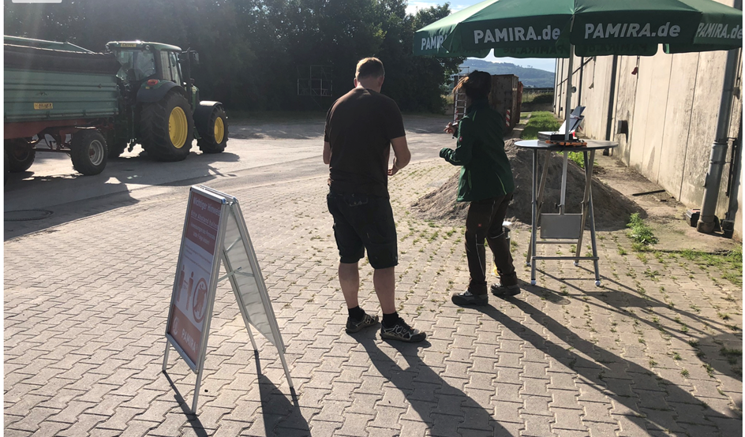
Since June 2020, instead of using a paper form, collection forms have been prepared conveniently using the PAMIRA app on the tablet and an interface for synchronisation in the existing customer database. The form can be digitally signed within a few seconds, printed out via a mobile printer and sent as a PDF at the same time if the customer's email address is provided. An inspector can now record significantly more recoveries at the same time and this greatly reduces waiting times for farmers, a win-win situation for all parties involved.
The project team was able to successfully overcome these three major challenges:
- Target group: it was extremely important here that the app contains all the necessary information, but at the same time offers good user-friendliness through a simple and self-explanatory design. Even if you don't handle tablets and apps every day.
- External conditions at collection points: since these are exclusively outdoor recoveries, where collections have to be carried out in unpredictable weather conditions and without an available internet connection, stable functionality is essential for the process.
- Clean integration of the process into the existing company architecture: in order for the collected data to be reliably transferred to the company's own CRM and to enhance the customer's master data, it was necessary to develop a high-performance and secure interface. In this context, the focus is not only on protecting our customer data with the highest security standards, but also on fulfilment of all legal requirements with regard to the General Data Protection Regulation.
For RIGK, it was an important and big step to approach such a project as an individual development. For this reason, the choice for the right implementation partner was made carefully. Implementation of the concept, through the design process to the technical development, took place with the companies IMMERWIEDERDESIGN and zauberware from a single source. A complete success!
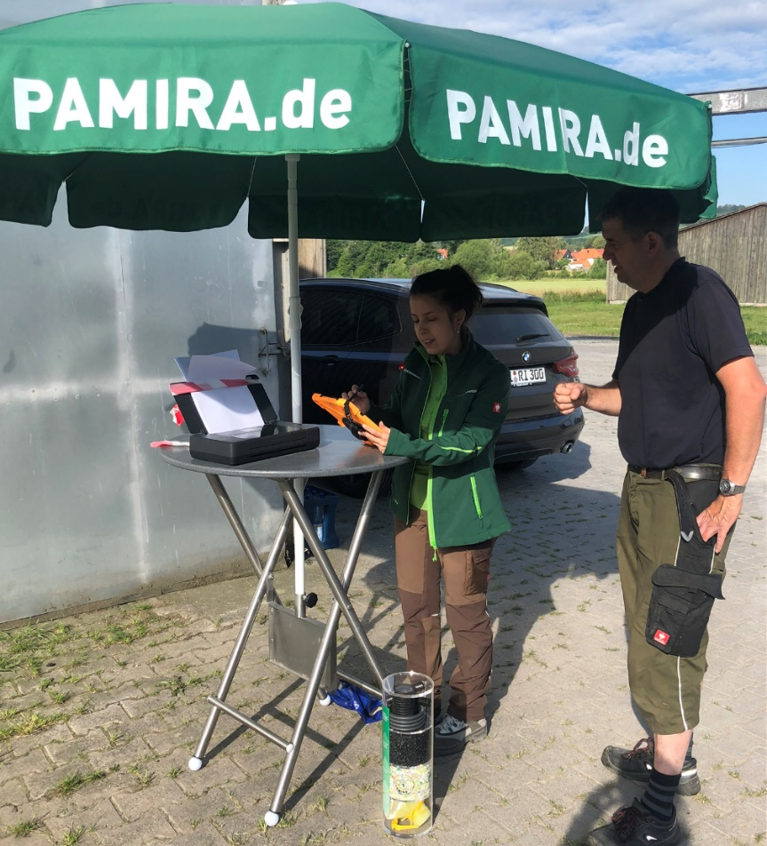

More information:
Thorsten Heil, System Manager PAMIRA
Tel.: +49 611 308600-17; heil@rigk.de; www.pamira.de

