In spite of the coronavirus, Crop Plastics Recycling Germany (ERDE) is extending collections even further in 2020 and is continuing the success achieved in 2019
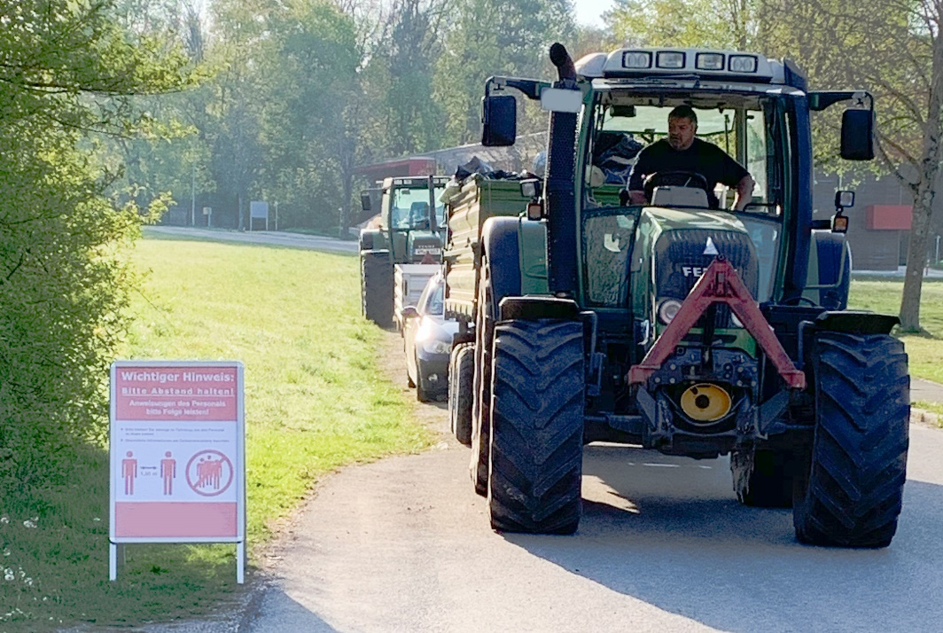
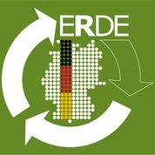
In spite of the coronavirus, ERDE collection points remain open – subject to hygiene requirements and with references to safety. Farmers' work is still being carried out even during the pandemic, therefore agricultural films are accruing without interruption during silaging. The environment and the climate are protected through the active participation of film manufacturers, farmers and collection points for returning and recovering used silo/stretch films and nets.
This is because each tonne of recycled silo and stretch film saves 1.28 tonnes of CO₂ - harmful greenhouse gases. This fact comes from independent scientists at the Fraunhofer Institute. This means that in the year 2019 20,534 tonnes of collected closed loop recycled films saved 28,210 tonnes of CO_{2.}

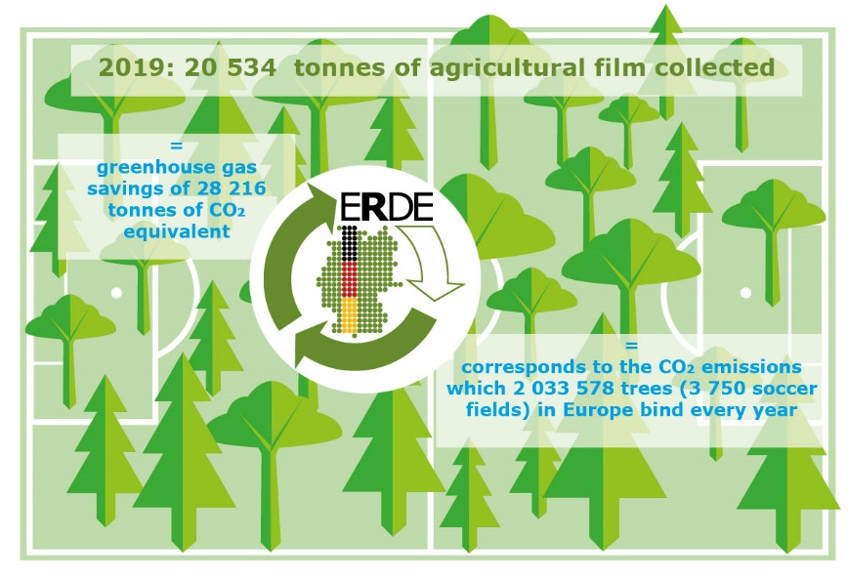
With a collected volume of 20,534 tonnes of agricultural films, in 2019 the ERDE initiative enabled greenhouse gas savings of 28,216 tonnes of CO₂ equivalent. This corresponds to the amount of carbon dioxide that around 2 million trees bind annually. © RIGK
Further information:

Boris Emmel, System Manager ERDE
Tel.: +49 6 11 30 86 00-20
emmel@rigk.de

