RIGK: Jan Bauer Member of the Management Board
Wiesbaden, September 2020 – The Administrative Board of RIGK GmbH has appointed Jan Bauer as a member of the Management Board with effect from 1 September 2020. At the same time, Markus Dambeck, the previous sole Managing Director, was named Chair of the Management Board.
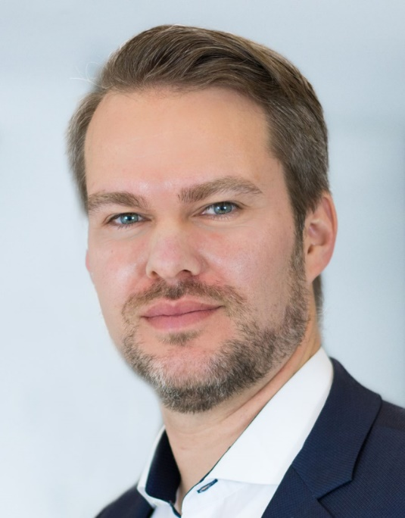 Jan Bauer ©RIGK
Bauer graduated in business management and joined RIGK in 2006, where he initially acquired experience in the branch in marketing and customer support. Following this, as a product manager, he oversaw the development of the RIGK-PICKUP system, the crop plastics recycling (ERDE) system and, after he was granted general power of representation in 2012 - he managed the RIGK branch in Chile. At the same time, he took over the commercial management of RIGK in Germany. Bauer has been a member of the Board of the European Association of Plastics Recycling and Recovery Organisations (EPRO) since 2019.
"With the recovery and closed loop circulation of plastics and packaging, RIGK is active in a subject area that has become more important and relevant in recent years in particular", states Bauer. "The road to efficient and sustainable closed loop recycling management for plastic is still faced with many challenges. We are pleased to support our customers in the process of change to sustainability."

