Disposal: PRE system recovers
unusable agricultural pesticides

Nationwide collection 2020 at 8 locations / dates and places in the Internet

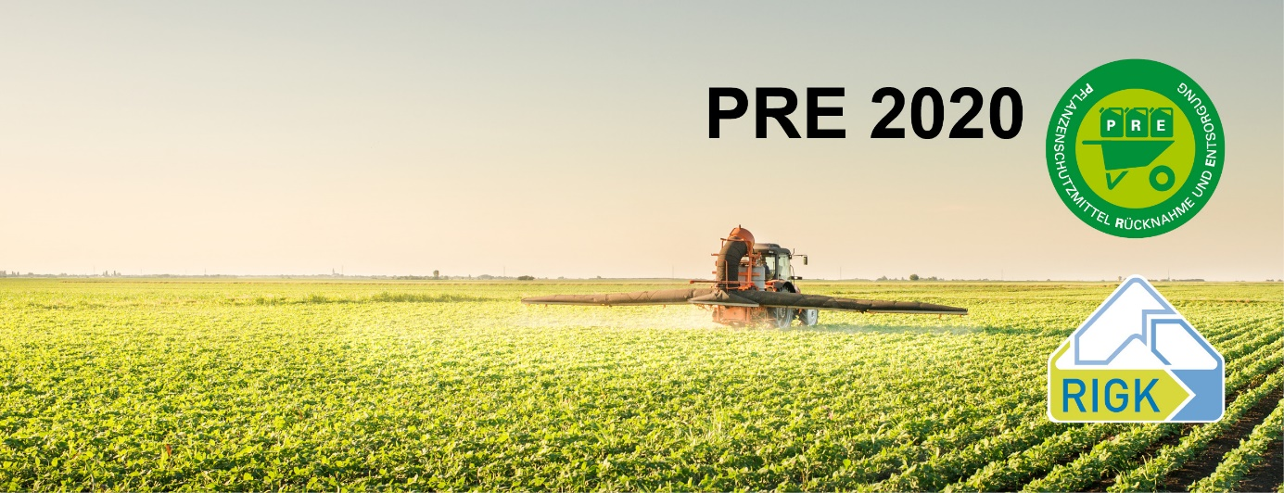

(Frankfurt a. M., 30. July 2020) This year as well there will be collections in November by the PRE® recovery system ("PRE" – initial letters of the German for recovery and recycling of agricultural pesticides). Obsolete agricultural pesticides will be recovered at eight locations throughout Germany. These include products that may no longer be used in Germany because their approval has expired, as well as other products that accrue in farming, for example other agrochemicals, cleaning agents, oils, seed dressings, fertilisers, dressed seeds, filters, greases and paint.

PRE was brought into being in 2013 by the Industrieverband Agrar e. V. (Agricultural Industries Association - IVA) in the framework of the sustainability initiatives of the German agricultural pesticide industry. Since the start of PRE, 247* tonnes of obsolete agricultural pesticide stocks have been recycled safely. Since its introduction, the system has been used by 1690 deliverers.

*(Together with earlier PRE projects, since 2006, 793 tonnes of obsolete agricultural pesticide stocks and other agricultural chemicals have been recovered from over 10,000 deliverers and recycled safely.)

The PRE system is a comprehensive solution for the safe disposal of obsolete agricultural pesticide stocks. PRE guarantees safe, prompt and environmentally correct recycling.

Further information on the PRE system, all collection points and dates for 2020, as well as the conditions for collections, can be found on the website
www.pre-service.de. Experts from the company RIGK GmbH, Wiesbaden, which has been entrusted with the implementation of the project, are available via the free service hotline 0800 3086001* to answer questions on the recovery and recycling of obsolete agricultural pesticides and other agricultural chemical stocks (Mon - Fri, 9a.m. – 5p.m., except on public holidays).

For logistical reasons, the mobile hazardous material collectors at the PRE collection points can accept a maximum of 1 tonne per deliverer. Naturally, more than 1 tonne can be disposed of via PRE. For this purpose, phone RIGK GmbH (0800 3086001*), to arrange individual disposal. There is a fee of EUR 2.95 kg/litre plus VAT for recovery. Payment is made by invoice. For this reason, the deliverer must have data for invoicing plus an identity card available when delivering. An acceptance certificate is issued as evidence of disposal for waste legislation purposes.

After collection, chemicals are brought by PRE to special waste incinerators approved for this purpose and disposed of there.

In addition, the 2020 collection season is ongoing for PAMIRA (formed from the initial letters of the German for "agricultural packaging recovery"), the disposal system for agricultural pesticide and liquid fertiliser packaging that is returned empty. At 380 collection points nationwide. In 2019, PAMIRA recycled a total of 2,955 tonnes of empty packaging of agricultural pesticides and other agricultural chemicals in an environmentally compatible manner and achieved the highest recovery quota to date of 80 percent.

Information on the PAMIRA system, all collection points and dates is available at www.pamira.de or in the PAMIRA APP.

The Industrieverband Agrar e. V. (Agricultural Industries Association - IVA) represents the interests of the agricultural chemicals industry in Germany. The business areas of the 53 member companies include agricultural pesticides, crop nutrition, organic stimulants and pest control. The sector represented by the IVA stands for innovative products for modern and sustainable farming.

*within Germany

Press contact:

Industrieverband Agrar e. V., Press Office
Maik Baumbach
Tel. +49 69 2556-1268 or +49 151 54417691
Fax +49 69 2556-1298
Email: baumbach.iva@vci.de
https://www.iva.de
https://twitter.com/IVA_Presse

