PRESS RELEASE
Nationwide collection of asparagus film starts in 2021

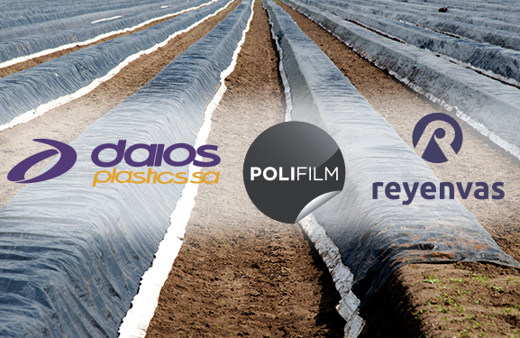
Asparagus films, along with silage films, stretch films, bale nets and baler twine, is now one of the plastic products used in agriculture collected by the ERDE initiative. © ERDE
Bad Homburg, March 2021
The ERDE initiative (Erntekunststoffe Recycling Deutschland: www.erde-recycling.de) is offering a nationwide service for the collection of used asparagus film starting this year's asparagus season.
After corresponding pilot projects were successful in two asparagus growing regions in 2020, the asparagus film producers and wholesalers organized in ERDE agreed on the implementation of a nationwide concept under the umbrella of the ERDE initiative. The system, operated by RIGK GmbH, offers a complete service from collection up to mechanical recycling. It includes monitoring of the material flows from collection to recycling, and supporting communication measures for asparagus farmers. Disposal costs for used asparagus film are determined by the collection partners listed on the ERDE homepage.
Monitoring and communication are funded by three asparagus film manufacturing companies and ERDE members, Daios Plastics, Polifilm and Reyenvas.
Dimitrios Daios, Managing Director of the eponymous Greek film manufacturer Daios Plastics S.A., emphasizes: "As a leading manufacturer of asparagus film in Europe, we are committed to a sustainable lifecycle of our products –from using recycled material in production and up to recycling of used film. We fully support ERDE's expansion of the collection to all of Germany, involving existing stand-alone solutions."
Sara Erlbacher, head of export sales at the Spanish film manufacturer Reyenvas S.A., emphasizes, "As a long-standing ERDE member and sponsor of one of the pilot projects in 2020, we welcome the uniform concept for communication that we agreed on among all stakeholders. Displays at the edge of the field, for example, will be used to provide information about collection and recycling. This will help preventing plastic from entering the environment. "
In recent years, asparagus film has been viewed critically by the public – especially by asparagus consumers. The use of asparagus film ensures an asparagus harvest earlier in the year, longer, and with higher yields. This, however, will only be feasible and acceptable for the consumer in the long run if the used film is completely returned to the raw material cycle after its 7-8 years of use.
Including the nationwide collection concept for asparagus film, the ERDE Initiative expands its collection portfolio to a total of five fractions: silage films, stretch film, bale nets, baler twine and asparagus film. The ERDE initiative currently works with relevant stakeholders on the step-by-step inclusion of further fractions.
The ERDE initiative was launched in 2013 by environmentally conscious film manufacturers in the IK Industrievereinigung Kunststoffverpackungen e.V.. Since then, ERDE is consistently pursuing its aim to collecting ALL types of crop plastics, finding environmentally sound recycling solutions, and informing politicians and the public about the results by means of transparent monitoring.

About ERDE
Under the umbrella of IK Industrievereinigung Kunststoffverpackungen e.V. and in cooperation with RIGK as the system operator, ERDE organises the recovery and recycling of used crop plastics, such as silage film, stretch film, asparagus film, bale nets and baler twine, through collection partners throughout Germany. Supply agencies and farmers collect the crop plastics, pack and deliver them – swept clean and free of the worst of the dirt – to a collection point (www.erde-recycling.de/rund-um-die-abgabe/sammelstellen-termine.html). Collection points set the collection prices individually. Recycling companies process the collected goods into new plastic feedstocks.
Any producer or distributor of crop plastics that supplies the German market can become an ERDE member. The following 21 companies take responsibility for their products and the environment as ERDE members: ape Europe, ASPLA S.A., Groupe Barbier, bpi agriculture, CLAAS Vertriebsgesellschaft mbH, Cordex - Companhia Industrial Textil S.A., Coveris Flexibles Austria GmbH, Daios Plastics S.A., DUOPLAST AG, KARATZIS S.A., Manupackaging Deutschland GmbH, NOVATEX, Plastika Kritis S.A., POLIFILM Extrusion GmbH, Ab Rani Plast Oy, Reyenvas S.A., RKW Agri GmbH & Co. KG, Sotrafa S.A., Tama Group, TRIOWORLD GmbH und WKI Tegafol Sp. z o.o.

Further information:

RIGK GmbH
Boris Emmel
ERDE System Officer
Friedrichstr. 6, D-65185 Wiesbaden
Tel.: +49 (0) 6 11/ 30 86 00-02, Fax: -30
emmel@rigk.de; www.rigk.de

