700 European companies and institutions have already joined the OCS programme to avoid losses of plastic granules and their release into the environment
PlasticsEurope promotes the initiative Operation Clean Sweep® (OCS), which leading plastics manufacturers and processors have also joined since 2015. By 2025, it is planned to have all member companies of PlasticsEurope audited externally
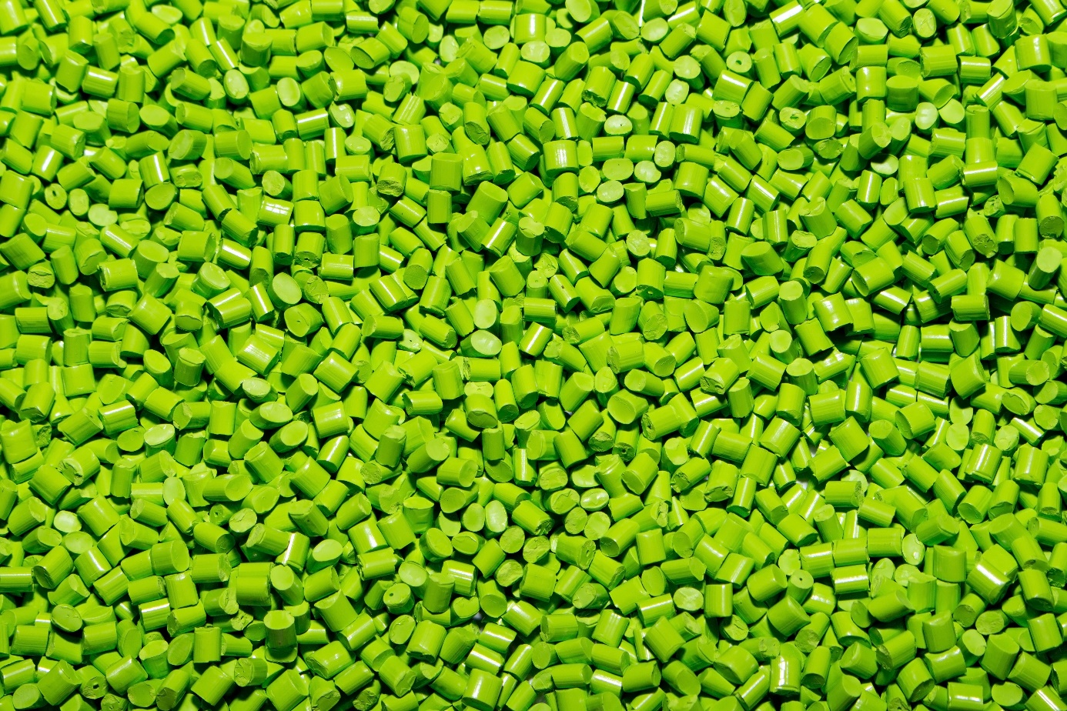
© RIGK
Since 2015, European plastics producers and other players in the value creation chain have been able to join the initiative “Operation Clean Sweep” (OCS) ((http://www.opcleansweep.eu/)), which originally started in North America 25 years ago. The aim of the programme is the strategy of “Zero Pellet Loss” Video zero pellet loss programme (ineos.com). This is intended to reduce pollution in bodies of water, the soil and roads caused by plastic granules (pellets, flakes and powder) formed on the basis of plastic products and ultimately to rule out their loss during transport, production and recycling. An important issue, particularly in view of the pollution of bodies of water with microplastic. According to one estimate in a study from Eunomia ((https://bmbf-plastik.de/sites/default/files/2018-04/microplastics_final_report_v5_full.pdf )), carried out in 2018, spilled or incorrectly transported plastic granules that are released into the environment are the second-largest source of microplastic in bodies of water.
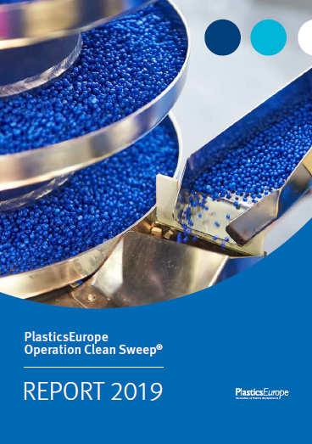
Copyright picture: PlasticsEurope
The 2019 progress report on the initiative Operation Clean Sweep from PlasticsEurope ((https://www.plasticseurope.org/de/resources/publications/4141-operation-clean-sweepr-progress-report-2019)) documents what has already been achieved and looks ahead at future further developments of the programme. According to the report, about 700 companies and institutions have joined the OCS programme, thus making an active contribution to minimising volumes of plastic granules in the environment. These consist of a variety of companies from the value creation chain: plastic manufacturers, transport and recycling companies and also those involved in transport infrastructure – for example in Cartagena and Tarragona in Spain as well as Felixstowe in the United Kingdom, three of the largest ports in Europe have joined the initiative.
Many companies from the RIGK clientele have committed themselves to the Operation Clean Sweep programme as members of PlasticsEurope. Dr Patrick Giefers, Managing Director of INEOS in Cologne and Chair of the Administrative Board of RIGK, explains their motivations: “Every single lost plastic granule is deemed to be unacceptable at all INEOS locations worldwide. For this reason, we committed ourselves to Operation Clean Sweep as early as 2016. In addition, with Zero Pellet Loss, INEOS strives to avoid the release of plastic granules into the environment – both at our own locations and also losses made by carriers and customers. Protecting bodies of water and the oceans in particular is increasingly important for the public as a whole. We want to make our active contribution to protecting the seas with the Operation Clean Sweep initiative.”

PlasticsEurope defines an action plan for the future
In the 2019 progress report on Operation Clean Sweep, Plastics Europe has also defined the next steps in the programme. On the one hand, contributing to the initiative will no longer be voluntary for companies that want to become members of the association, but mandatory. According to its own statement, this makes PlasticsEurope the first association worldwide with such strict requirements. On the other hand, PlasticsEurope has also presented an action plan for a “2022 Zero Pellet Loss” certification system in the 2019 OCS progress report. Its aim is to define binding requirements for companies, based on the six OCS commitments (http://www.opcleansweep.eu/the-program/) and to implement these. Going forward, by 2025 it is intended that all member companies of PlasticsEurope will have been audited and certified for compliance with these OCS commitments by independent and external experts.
President Dr Markus Steilemann underlines the importance of the Operation Clean Sweep initiative to PlasticsEurope: “Avoiding the loss of plastic granules is a key pillar of our sustainability strategy. Our common aim is ruling out all losses of pellets into the environment.”

Further information:
Claudia Hoese,
Customer Relationship Manager / Public Relations Manager
Tel.: +49 611 308600-12
hoese@rigk.de

