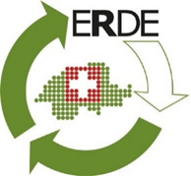
Recycling of Swiss agricultural films picks up speed

Recycling of silage films in Switzerland will be massively expanded by ERDE Switzerland from January 2022.

Proven system
Of the 6,000 to 10,000 tonnes of construction and agricultural film consumed annually in Switzerland only smaller quantities were recycled in 2019. Kurt Röschli, Managing Director of the KUNSTSTOFF.swiss association, has taken up the cause of bringing this unused potential back into the cycle. Agricultural films are produced in various EU countries and imported into Switzerland. Kurt Röschli, Managing Director of the KUNSTSTOFF.swiss association, therefore looked around in the EU and quickly came across an established system, the German initiative ERDE, which is now to be adopted in Switzerland in cooperation with ERDE Germany and the system operator RIGK. Under the name ERDE Switzerland, the silo/stretch film as well as nets are to be collected and, where recycling capacities in Switzerland are already exhausted, exported to specialised recycling companies in the EU. The system is financed by subsidies from the manufacturers. These contributions, which are in principle advance recycling fees, are received by the collection points in order to keep the total expenditure in logistics and further processing for the disposal company as low as possible.

Independent association
The independent association ERDE Schweiz, under the leadership of Kurt Röschli and as an associated member of the umbrella organisation KUNSTSTOFF.swiss, will ensure, in exchange with the authorities and the system operator RIGK, that the system becomes operational on 1 January 2022. The new association is made up of manufacturers, traders, disposal companies and the Swiss Contractors Association. At the founding meeting on 14.07.21 in Aarau, 14 founding members have already joined the new association.

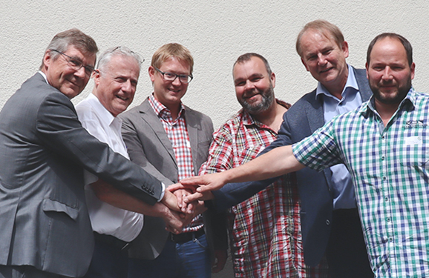
The Board of ERDE Switzerland: (from left to right) Jürgen Bruder (IK), Kurt Röschli (KUNSTSTOFF.swiss),
Johannes Frauscher (Berry bpi agriculture), Daniel Haffa (Contractors Switzerland), Franz-Josef Lichte (Trioworld GmbH), Marcel Herzog (Herzog Hornussen AG)

About ERDE - Harvest Plastics Recycling Germany
Under the umbrella of IK Industrievereinigung Kunststoffverpackungen e.V. [Industrial Association Plastic Packaging] and in cooperation with RIGK as the system operator, ERDE organises the separate return and recycling of used crop plastics such as silage flat film, stretch film, asparagus film, perforated film, fleeces, bale nets and baler twine via collection partners throughout Germany. Contractors and farmers collect the crop plastics and hand them in bundled - broom-clean and freed from coarse dirt - at a collection point (https://www.erde-recycling.de/en/return-crop-plastics/find-erde-collection-points/). The acceptance price is set directly by the collection point. Recycling companies then process the collected material into new plastic raw materials.

Any manufacturer or primary distributor of crop plastics who supplies the German market can become a member of ERDE. The following 23 companies assume responsibility for their products and the environment as ERDE members: ASPLA S.A., Groupe Barbier, Berry bpi agriculture, CLAAS Vertriebsgesellschaft mbH, Cordex - Companhia Industrial Textil S.A., Coveris Flexibles Austria GmbH, Daios Plastics S.A., DUOPLAST AG, KARATZIS S.A., Manupackaging Deutschland GmbH, NOVATEX, PIIPPO OYJ, Plastika Kritis S.A., POLIFILM Extrusion GmbH, Ab Rani Plast Oy, Reyenvas S.A., RKW Agri GmbH & Co. KG, Sotrafa S.A., Tama Group, Tecfil S.A., Tencate, TRIOWORLD GmbH and WKI Tegafol Sp. z o.o.

