RIGK – your specialist for recovering hazardous packaging and packaging of dangerous goods
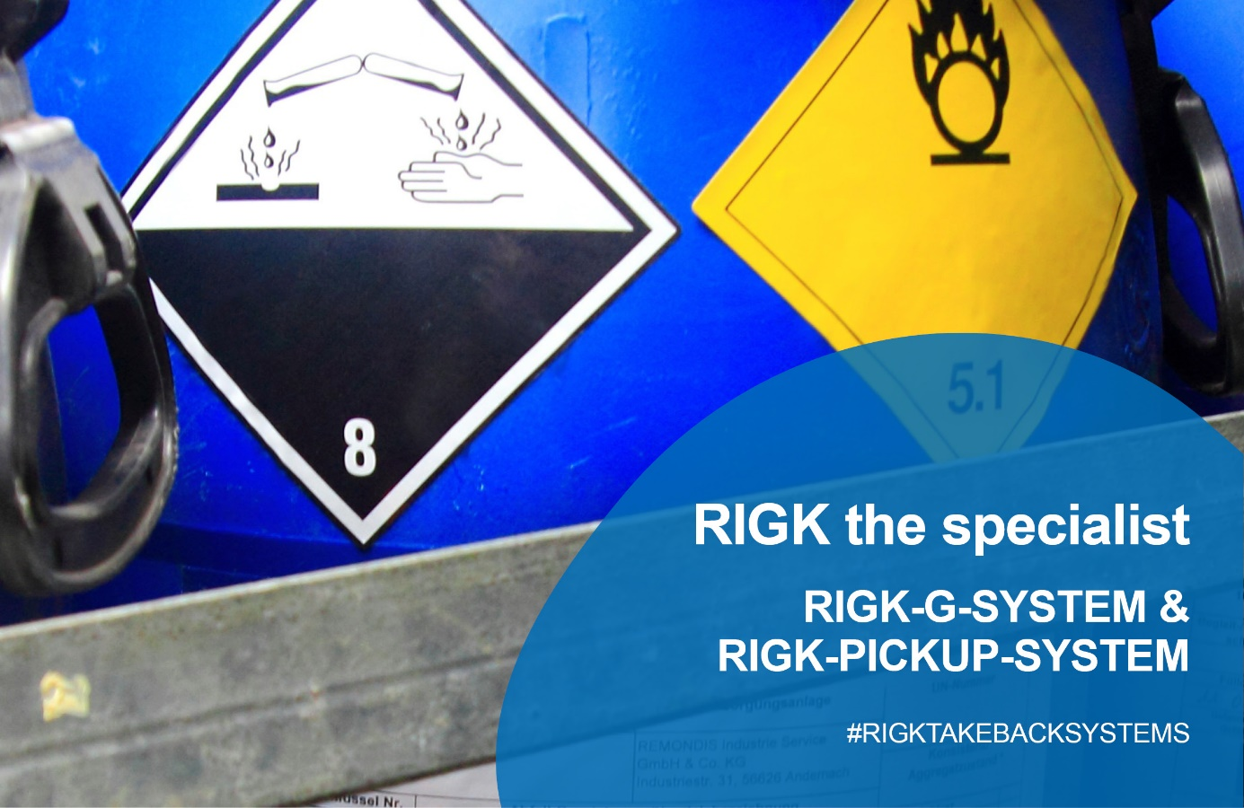
The amendment to the German Packaging Act has already been in force since 3 July 2021, and this year additional new obligations for handling industrial, transport and commercial packaging are coming into force. These obligations focus on packaging for hazardous goods in particular. They require compliance with additional legal regulations with regard to emptying packaging, pollution caused by hazardous substances and environmental protection during the recovery and recycling process. RIGK customers can rely on two proven and legally-compliant systems for this packaging: the RIGK-G-SYSTEM and the PICKUP-SYSTEM. Thanks to the packaging licensed in the RIGK systems, the producers and distributors of packed products will be ideally equipped for the new regulations, because these systems already meet all the requirements. Where this is not possible, RIGK offers individual solutions as a service.
Materials and recycling considerations are at the forefront for all RIGK recovery systems. The Wiesbaden company recycles the packaging it collects wherever possible so it stays in the material cycle, making a contribution to active environmental protection.
The RIGK-G-SYSTEM (where “G” is the abbreviation for hazardous in German) is the solution for packers and distributors of products containing hazardous substances. RIGK recovers and recycles packaging with this system – safely, cost-effectively and in compliance with the law. The system is based on a licensing model, in which a logo is applied to the packaging, which identifies it in the take back cycle and approves it for the recovery process. After handing in the packaging, it is subjected to energetic recovery. Recovery is carried out through collection points throughout Germany in cooperation with certified waste disposal partners.
In the RIGK-PICKUP-SYSTEM, which also works with a trademark printed on the packaging, RIGK collects packaging containing hazardous and non-hazardous substances on request directly on site at the commercial end customers’ premises. Through RIGK-PICKUP, RIGK and a pool of partners collect packaging from commercial end customers and recycle it safely and in compliance with the law - free of charge for the waste producer. After collection, the packaging is recycled depending on the degree of contamination, varietal purity and contamination with hazardous substances. Packaging containing non-hazardous substances and unmixed packaging is turned into granulate in order to manufacture new plastic products. Packaging containing hazardous substances is usually subjected to energetic recovery in order to generate electricity, steam and district heat.
You will find further information about the RIGK systems and recycling packaging of goods containing hazardous substances on the website at:
RIGK-G-SYSTEM: https://www.rigk.de/en/recovery-systems/recovery-systems-for-producer-and-packaging-companies/detail/rigk-g-system
PICKUP-SYSTEM: https://www.rigk.de/en/recovery-systems/recovery-systems-for-producer-and-packaging-companies/detail/rigk-pickup
or contact RIGK directly. Together with you RIGK will find the right solution for your packaging - within the scope of the recovery systems or with an individual solution. You can reach us through the following contact.

More information:
RIGK GmbH
Volkmar Löber
Sales Manager
Friedrichstr. 6, 65185 Wiesbaden
Phone: +49 611 308600-36
loeber@rigk.de; www.rigk.de/en/

