NEWS RELEASE
RIGK at IFAT 2022:
30 years of producer-funded recovery systems to encourage recycling – a clear focus on cooperation
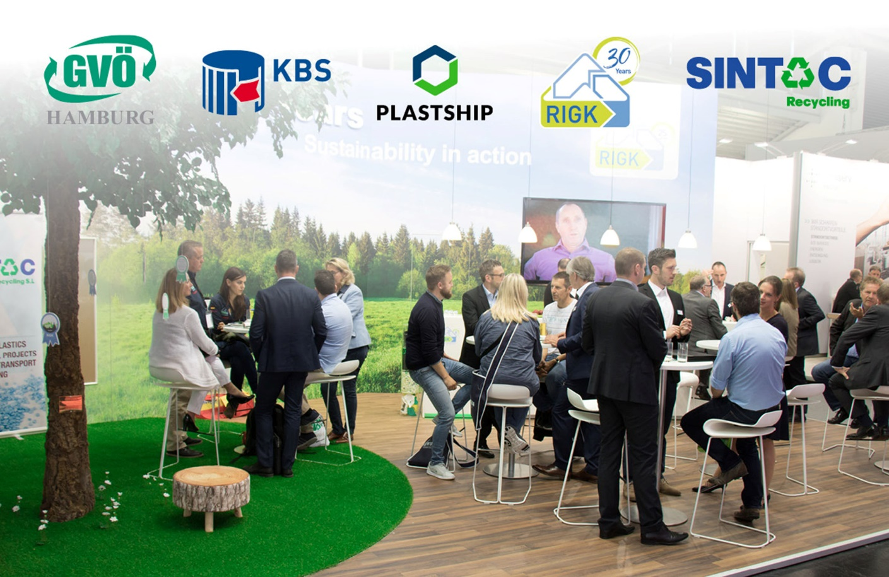
At IFAT, RIGK and its co-exhibitors offer space and time for discussions; © RIGK
Wiesbaden, Germany, March 2022 – On the occasion of its 30th anniversary, RIGK will be at IFAT (the World's Leading Trade Fair for Water, Sewage, Waste and Raw Materials Management) in Munich from 30 May to 3 June 2022 to showcase solutions and cooperation arrangements connected with its EPR systems (extended producers´ responsibility) for used packaging and plastics. Another focus will be on the company's possibilities to develop individual recovery and recycling solutions, both at national and international level.
Strengthening cooperation
"Circular economy needs cooperation" is the motto RIGK will use on their stand no 316 in Hall A6 to initiate and promote interdisciplinary projects with the aim of jointly finding solutions to encourage recycling. The wide variety of possibilities that open up for this will also be shown by a number of other co-exhibitors, namely the company’s Romanian subsidiary RIGK SRL, the recycling company Sintac – RIGK's partner in Spain, the industry network and RIGK affiliate plastship, and the industry-specific recovery systems GVÖ (Gebinde-Verwertungsgesellschaft der Mineralölwirtschaft mbH) and KBS (Kreislaufsystem Blechverpackungen Stahl GmbH).
Advice on the amendment to the packaging legislation
At IFAT, these companies will give advice about the various ways in which producers can assume responsibility for the entire life cycle of their products, including the recovery and reuse/recycling, not only to satisfy their own demands but also to comply with the present and expected legal requirements. Especially regarding the amendment of the German packaging act (VerpackG), RIGK will demonstrate how participation in the EPR systems makes it easier to meet the additional obligations when handling industrial packaging, transport packaging and secondary packaging. RIGK will inform trade fair visitors about the latest developments, explain the new rules and regulations, and provide advice on their implementation.
RIGK’s Managing Director Markus Dambeck explains: "For producers or sellers of packaged industrial or trade products, the amendment to the legislation involves an information obligation, burden of proof, registration commitment and financing obligation. For many of the parties affected, this is complex and confusing. In cooperation with RIGK, the most efficient solutions for every company can be found to reliably avoid the risk of fines in implementing them.
30 years in the service of the circular economy
In 2022, RIGK marked 30 years of commitment to the safe and legally compliant recycling of packaging and plastics in the interests of sustainability and resource conservation. With its recovery systems, RIGK makes a valuable contribution in the battle against climate change. The spectrum ranges from packaging and plastics from industry, agriculture, and commerce to the recovery of unusable crop protection agents and chemicals in the agricultural sector.
- Under the ‘RIGK Industry’ label, the company combines its recovery systems for customers from trade and industry. These are the RIGK-SYSTEM and RIGK-G SYSTEM for the recovery of used and completely empty packaging for non-hazardous and hazardous substances, as well as the RIGK-PICKUP SYSTEM for the collection of empty packaging directly on site.
- The ‘RIGK Agrar’ label stands for the recovery systems for agriculture – the PRE-SYSTEM for the reliable recovery of unusable crop protection agents and other chemicals, ERDE Recycling for the recovery of used plastics, PAMIRA SEED DRESSINGS for the recovery of seed dressing packaging, and the PAMIRA-SYSTEM for the recovery of pesticide cans and liquid fertilisers` packaging.
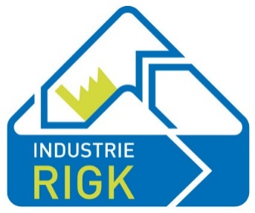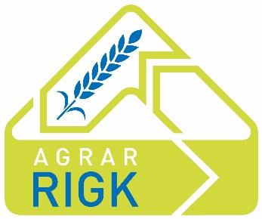
Dambeck continues: "In future, too, RIGK will invest its innovative strength and know-how in the development of ever more efficient solutions. The focus will continue to be on the recovery, reuse and recycling of packaging and plastics in order to close material life cycles and conserve resources. We are in constant dialogue with representatives from politics, industry, and research, and we participate in national and international networks because we know that our actions today will determine the world of tomorrow. We look forward to many interesting discussions and new ideas."
About RIGK
As a certified specialist for the operation of collection systems for the recovery and recycling of industrial and commercial packaging and plastics, RIGK GmbH, founded in 1992, organises the recovery of used, empty packaging and plastics and ensures their safe and sustainable recycling. Apart from that, the company provides consulting services in the development of customised reuse and recycling solutions. Internationally, RIGK is represented in Romania (www.rigk.ro), where it also deals with the recovery and recycling of used packaging and plastics. The shareholders of RIGK GmbH are well-known producers of plastics and packaging. Since 2006, RIGK GmbH has been a member of EPRO, where it also founded the working group for the recycling of agricultural plastic waste. RIGK also hosts the International Recycling Forum in Wiesbaden. The Wiesbaden-based RIGK company is a shareholder of plastship (www.plastship.com), which operates the online platform for tapping new markets for recycled plastic.
Further information:  RIGK GmbH  Claudia Hoese  Friedrichstr. 6  D-65185 Wiesbaden  Phone: +49 (0) 6 11/ 30 86 00-12  hoese@rigk.de; www.rigk.de | Editorial contact, and please send voucher copies to:  Konsens PR GmbH & Co. KG  Dr.-Ing. Jörg Wolters  Im Kühlen Grund 10  D-64823 Groß-Umstadt  Phone: +49 (0) 60 78/93 63-13  mail@konsens.de; www.konsens.de
Please find this press release (docx-file) and the image for download at https://www.rigk.de/en/worth-knowing/press

