RIGK Newsletter – BRITA contribution
Date: 2022-03-04
DRAFT, FINAL

Collaboration between water filter manufacturer BRITA and take back system operator RIGK to recycle filter cartridges
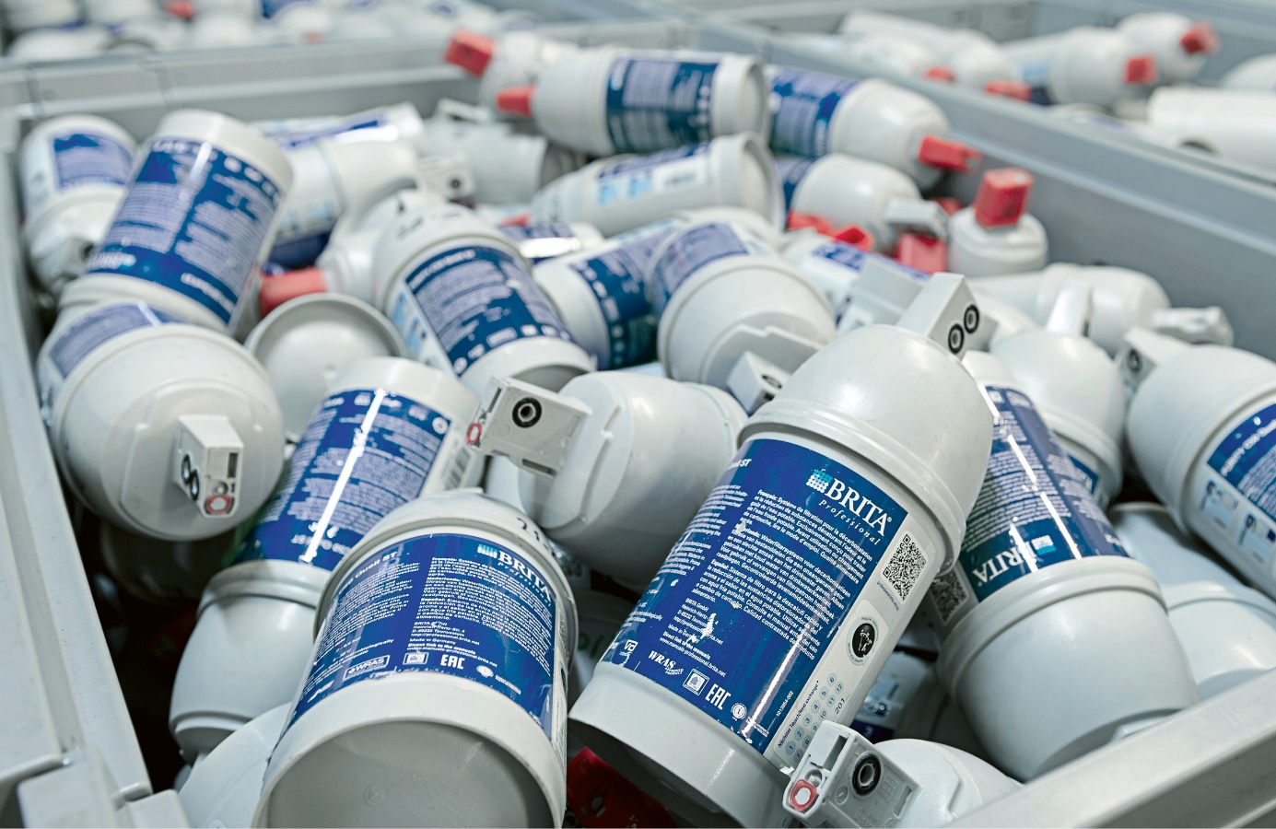
The family business BRITA has produced water filter systems for commercial and private users since 1966. One important area of the product portfolio is filter systems for commercial customers. The Purity C filter type is a special filter solution for commercial applications, such as in the hospitality trade, and works on the basis of the ion exchanger principle. This means the filter cartridge has to be exchanged after about one year, regardless of how and for how long it has been used.
BRITA has committed itself for many years to more sustainability in its products and during their manufacture. For example, a system was installed to enable used Purity C filter cartridges to be recycled. The water filter manufacturer BRITA works closely with RIGK to recycle the plastic parts and in waste disposal. Here, BRITA trusts RIGK’s experience with collection systems, recycling solutions and an outstanding network in the recycling industry.
BRITA has put sustainability at the core of its corporate strategy from 2020 to 2025. Yet a sustainability concept had already been installed many years earlier. For example, recycling Purity C filter cartridges has been part of the life cycle of this product since 2006.
The collaboration with RIGK to recycle the filter cartridges started in 2015 and impressively demonstrates that BRITA has been working on improving the sustainability of its systems and is now also consolidating this topic with partner companies.
“Our collaboration with RIGK has been very rewarding to date. It has made it possible for us to find recycling paths for products that we could never have opened up without this partnership approach. Joint experiments and expert dialogue about materials and the possibilities of recycling them are also considered when developing new products,” says Stephan Herbst, Head of the Health, Safety and Environment Department at BRITA.
The basic material of the Purity C filters is reinforced polypropylene. This material has to be very strong in order to withstand the pressure in the water filter systems, but this also creates greater effort when recycling plastic.
The filter consists of a head filled with a fine filter and activated carbon, and a body that contains synthetic resin and a coarse filter. The individual components have to be separated in order to recycle the filter. The precondition for this is taking back used filters.
As the basis of the recycling process, customers can send used filter cartridges back to BRITA free of charge or hand them in to collection points. This is often done by BRITA customer service itself. After collecting and recovering the filter cartridges, the in-house BRITA separating plant opens these and empties the active carbon and other filter substances. BRITA regenerates the ion exchangers recovered during this process itself and uses them in new products. On the other hand, RIGK takes over the plastic housings, which are then treated by commissioned partner companies. The aim here is to separate residues and to manufacture a defined plastic recyclate. RIGK markets this to plastic processors in the processing chain. In the next step these companies process the plastic recyclate to form an unmixed plastic granulate/compound used to manufacture new products.
One important and critical precondition for the success and sustainability of a recycling system is reaching the highest possible purity of the plastic recyclate obtained. Only a high purity recyclate can be reused flexibly in new products. The high quality standards of BRITA GmbH and close interlinking with the services from RIGK GmbH guarantee the manufacture of a pure recyclate that can provide the feedstock basis of new products.
RIGK GmbH operates a large number of recovery systems for packaging from industry, trade and agriculture and also offers individual recycling solutions. BRITA uses this service from RIGK with the aim of mechanically recycling all plastics as far as possible, thus strengthening the credibility of its sustainability activities.
You will find more information about the recycling ranges from BRITA here: https://www.brita.de/recycling-professional

Are you interested in an individual recycling solution? Get in touch with us: https://www.rigk.de/en/about-rigk/consultation-and-individual-solutions

More information:
RIGK GmbH
Claudia Hoese
Customer Relationship Manager / Public Relations Manager
Friedrichstr. 6, 65185 Wiesbaden
Phone: +49 611 308600-12
hoese@rigk.de; www.rigk.de/en/

