**PRESS RELEASE**

RIGK at PRSE 2025 – Shaping the future of the circular economy

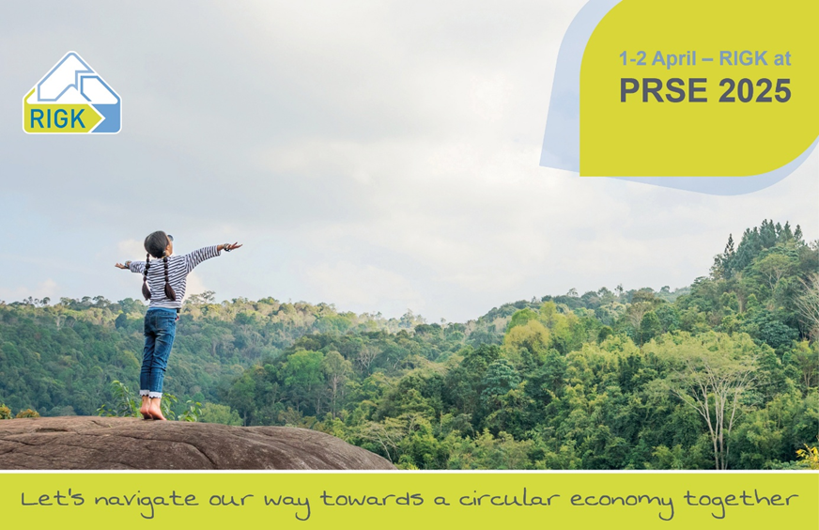

*© RIGK*

Wiesbaden, February 2025 – At the [Plastics Recycling Show Europe (PRSE)](https://www.prseventeurope.com/prseurope2025/en/page/home" \t "_blank), taking place on April 1-2, 2025, in Amsterdam, RIGK, its subsidiaries [plastship GmbH](https://plastship.com/en/), [Hannawald Plastik GmbH](https://hannawaldplastikgmbh.de/), and its certification division [PlastCert](https://www.rigk.de/en/about-rigk/plastcert-certification-testing) will focus on comprehensive solutions for the circular economy. Under the motto *"Let’s navigate our way towards a circular economy together"*, the group will showcase a broad range of services, covering everything from design for recycling and the collection and licensing of packaging to the development and operation of reuse systems, the certification of plastics, and the distribution of recyclates. The spotlight will be on innovative, practical strategies for promoting closed material loops.

Jan Bauer, Managing Director of RIGK, comments: "The PRSE provides an ideal opportunity to exchange knowledge and engage with experts, companies, and industry decision-makers on sustainable recycling concepts. With the implementation of the PPWR, this dialogue is now more crucial than ever."

**PPWR: Challenges and opportunities for the industry**

The new [EU Packaging and Packaging Waste Regulation (PPWR)](https://www.rigk.de/en/worth-knowing/news/the-new-eu-packaging-regulation-ppwr-what-does-it-mean-for-your-business), which came into force in February 2025, places increased demands on businesses. Stricter recycling requirements, mandatory quotas for recycled plastics, and a stronger focus on reusable packaging require adjustments but also offer the chance to drive the development of sustainable packaging solutions. RIGK supports companies in meeting these new requirements with tailored solutions that will be presented and explored in depth at PRSE.

**Advancing the circular economy together**

Beyond PRSE, RIGK remains committed to optimizing recycling processes and improving the quality of recyclates. In addition to further developing established take-back systems and fostering international cooperation, the company is also driving forward regional [projects and initiatives such as KISS and KARE](https://www.rigk.de/en/worth-knowing/news/rigk-sets-clear-priorities-for-2025-adopting-a-holistic-approach-for-an-effective-circular-economy-with-plastics) to strengthen resource cycles sustainably.

Ein Bild, das Text, Schrift, Screenshot, Grafiken enthält.
"A functioning circular economy can only be achieved through close collaboration across the entire value chain," adds Markus Dambeck, CEO of RIGK. "We look forward to engaging with the industry at PRSE and advancing this mission together."

PRSE 2025 provides a platform to discuss current developments and innovative concepts for the circular economy. More information and options for scheduling appointments can be found on RIGK’s **[PRSE landing page](https://www.rigk.de/en/prse-2025)**.

|  |  |
| --- | --- |
| Further information:  RIGK GmbH  Jan Bauer (Geschäftsführer)  Friedrichstr. 6  D-65185 Wiesbaden (Germany)  Phone: +49 (0) 6 11/ 30 86 00-0  bauer@rigk.de; [www.rigk.de/en/](http://www.rigk.de/en/) | Editorial contact, specimen copies:  Konsens PR GmbH & Co. KG  Dr.-Ing. Jörg Wolters Hans-Böckler-Straße 20  D-63811 Stockstadt (Germany)  Phone: +49 (0) 60 27/99005-13  [mail@konsens.de](mailto:mail@konsens.de); www.konsens.de |

This press release is available as a downloadable DOC file, along with high-resolution images, at https://www.rigk.de/en/worth-knowing/press