**PRESS RELEASE**

New collection group for a closed-loop economy: Greenhouse films now part of the ERDE system

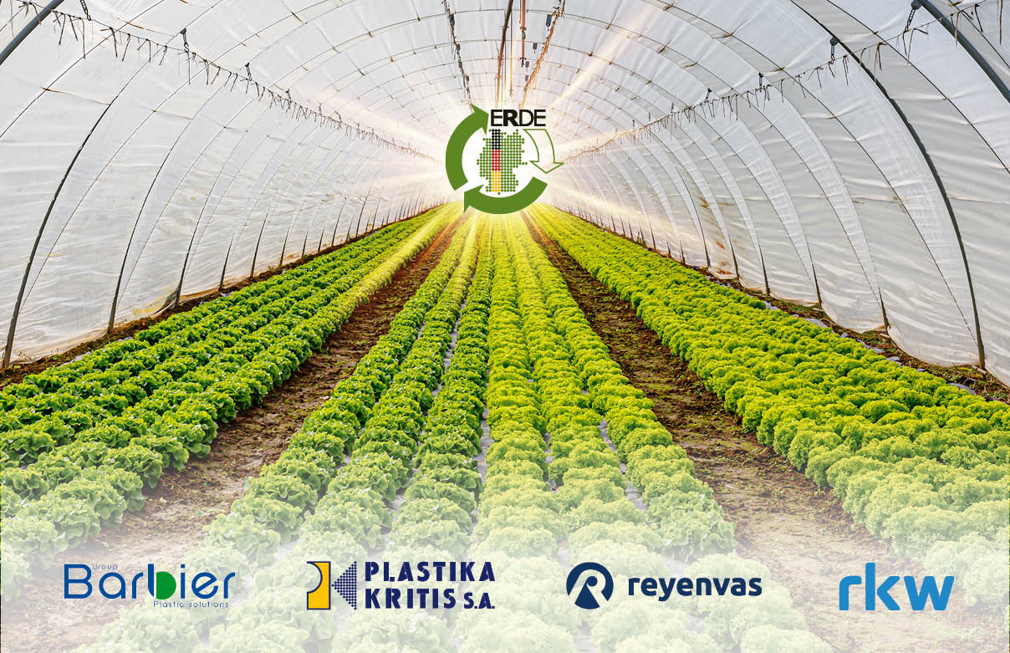

*The ERDE initiative continues its successful journey! © RIGK*

Wiesbaden, Bad Homburg, May 2025 – As of now, agricultural businesses can also return used greenhouse films in an environmentally sound manner through the established ERDE system, thereby actively contributing to the circular economy. This addition closes a gap in the take-back scheme for agricultural plastic products.

After collection, the films are recycled by specialised European recycling partners into high-quality recyclate – a valuable secondary raw material that flows back into the production of new greenhouse films or other film applications. The initiative not only promotes resource conservation but also offers farmers another practical opportunity to take responsibility for used plastics.

In addition to Plastika Kritis, which supported pilot collections last year, further manufacturers such as Groupe Barbier, RKW SE and Reyenvas are now committed to enabling a sustainable recycling solution for these large-scale agricultural plastics. Boris Emmel, system manager of the ERDE initiative, comments:  
“With this expansion of our collection system, we are once again setting a milestone for sustainable recycling in agriculture. Thanks to close collaboration with our partners, we have established efficient return and recycling routes. We would also like to thank the supporters of last year’s pilot project.”

**Strong partnerships – measurable impact**

The success of the new collection category for greenhouse films demonstrates the importance of cooperation among all players along the value chain: manufacturers, distributors, collection partners, and farmers are working closely together to make a functioning circular economy possible. Clean and sorted collection is key to ensuring high-quality recycling – and ERDE actively supports this through information campaigns and training on proper handling.

With around 700 collection points and over 150 collection partners, the take-back system is already well-established across the country and continues to expand wherever needed in practice. Additionally, the new ERDE premium label promotes [particularly committed distribution partners](https://www.erde-recycling.de/en/take-back-system/100-partner/) who meet the highest sustainability standards by selling only ERDE-licensed products.

**Climate protection made easy: Recycle greenhouse films now**

Recycling used greenhouse films not only helps reduce plastic waste but also cuts significant amounts of greenhouse gas emissions. In 2024, the return of 39,940 tonnes of agricultural plastics resulted in [savings of approximately 37,258 tonnes of CO₂ equivalents](https://www.erde-recycling.de/en/erde-news/successful-balance-2024-nearly-40000-tonnes-of-agricultural-plastics-recycled-through-initiative-erde/) – roughly equal to 324 million car kilometres or the carbon sequestration capacity of over 2.6 million trees.

Agricultural businesses, distributors and collection partners are invited to get involved. If farms have used greenhouse films for disposal, they can simply get in touch and the materials will be directed into proper recycling processes.

|  |  |
| --- | --- |
| Further information:  ERDE initiative  Boris Emmel, system manager  Friedrichstr. 6  65185 Wiesbaden (Germany)  Phone.: +49 611 308600-20  [emmel@rigk.de](mailto:emmel@rigk.de), [www.erde-recycling.de](http://www.erde-recycling.de) | Press contact, sample copies:  Konsens PR GmbH & Co. KG  Dr.-Ing. Jörg Wolters  Hans-Böckler-Straße 20  63811 Stockstadt (Germany)  Phone: +49 6027/99005-13  [mail@konsens.de](mailto:mail@konsens.de); [www.konsens.de](http://www.konsens.de) |

You can download this press release as a Word file along with print-quality images at: https://www.rigk.de/en/worth-knowing/press