**PRESS RELEASE**

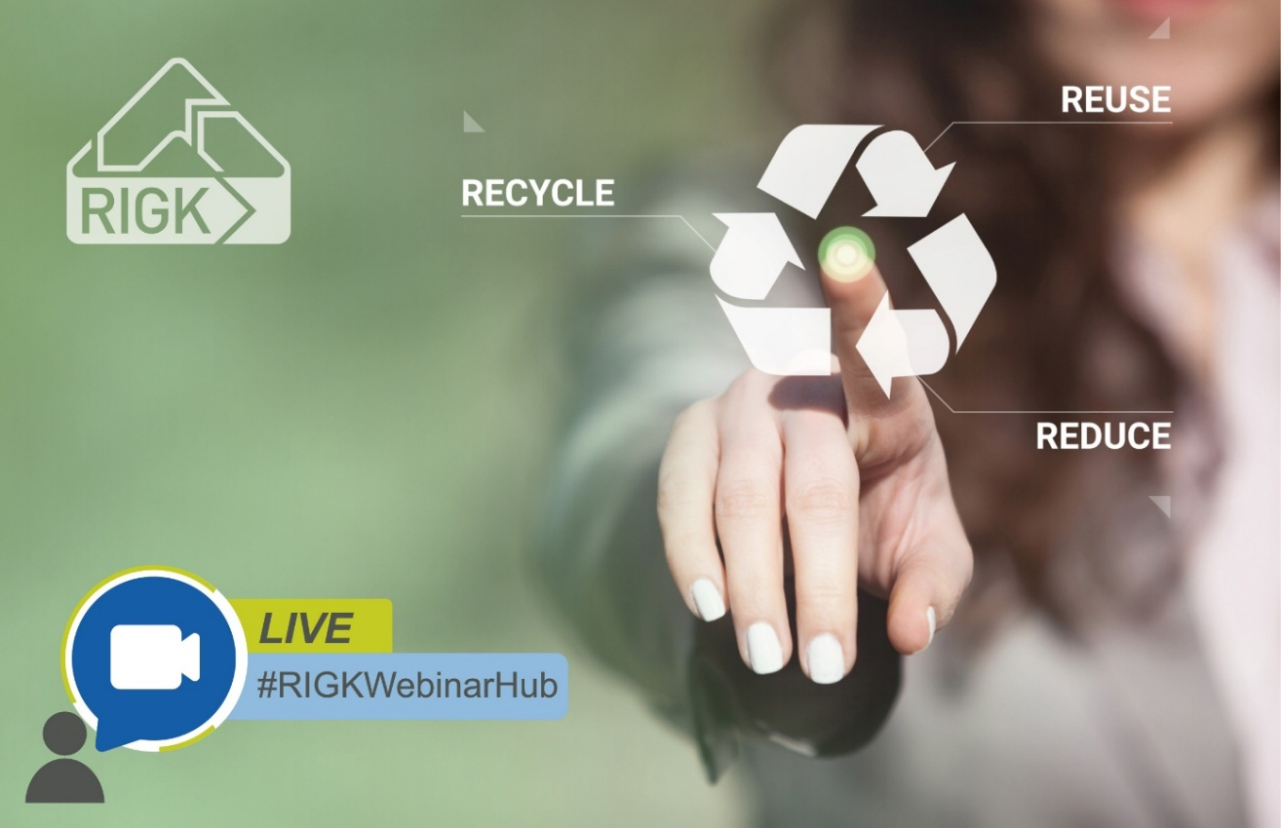#RIGKWebinarHub:   
New free webinar series launches with a focus on the EU Packaging and Packaging Waste Regulation (PPWR)

*The new “#RIGKWebinarHub” combines practical know-how with strategic perspectives for the packaging industry. © RIGK*

Wiesbaden, August 2025 – The new EU Packaging and Packaging Waste Regulation (PPWR) introduces far-reaching changes for companies across Europe. Which requirements will need to be met in future, and how practical solutions along the entire plastics cycle can be implemented, will be the focus of RIGK’s opening webinar in its new series #RIGKWebinarHub on 11 September 2025. The online session is aimed at packaging manufacturers, distributors, retailers and recyclers, and will take place from 10:00 to 11:30 a.m. (CET). Participation is free of charge, the webinar will be held in English. Registration is required and can be completed at <https://www.rigk.de/en/rigkwebinarhub>.

Under the theme *“Future-Proof Packaging: How to Close the Loop and Meet PPWR Standards”*, experts from the RIGK network will present strategies for successfully implementing the new regulatory requirements across industry, commerce and agriculture. Participants will gain a concise overview while also discovering concrete courses of action. These range from packaging take-back and licensing, through PPWR consulting services, to certification of recycled content, design for recycling and recycling processes. In addition, the procurement of high-quality recyclates by plastship in new applications will be addressed.

**From compliance to circularity: programme highlights**

Participants can expect compact presentations on the PPWR’s key action areas:

* Introduction to the PPWR – relevance, opportunities and required actions for companies (Jan Bauer, RIGK GmbH)
* Take-back systems for C&I packaging – time-tested solutions developed by industry for industry & commerce (Claudia Hoese, RIGK GmbH)
* Agricultural take-back systems – successful models such as PAMIRA, ERDE & others (Markus Dambeck, RIGK GmbH)
* AI-supported material flow optimisation (KISS Project) – digitalisation for improved circularity (Andreas Bastian, plastship GmbH)
* Certification & material assessment – demonstrating recyclability, recycled content and recycling processes (Konstantin Humm, PlastCert division, RIGK GmbH)
* PPWR consulting service – obligations and practical support for producers and manufacturers (Maria Hentze, PACKLIANCE GmbH i.f.)

The session will conclude with a moderated live Q&A, giving participants the opportunity to discuss individual questions directly with the speakers.

**Practical, solution-oriented, connected**

Jan Bauer, Managing Director of RIGK, comments: “With the PPWR, a new phase of the European circular economy begins. Our aim is to inform businesses about their obligations and provide them with practical tools to successfully meet the new requirements. The #RIGKWebinarHub is designed as a platform for knowledge, exchange and networking.”

Further information:

|  |  |
| --- | --- |
| RIGK GmbH  Jan Bauer (Managing Director)  Friedrichstraße 6  65185 Wiesbaden (Germany)  Phone: +49 (0) 6 11/ 30 86 00-56  [bauer@rigk.de](mailto:bauer@rigk.de); <https://www.rigk.de/en/> | Press contact / copies requested:  Konsens PR GmbH & Co. KG  Dr.-Ing. Jörg Wolters Hans-Böckler-Straße 20  63811 Stockstadt (Germany)  Phone: +49 (0) 60 27/99005-13  [mail@konsens.de](mailto:mail@konsens.de); [www.konsens.de](http://www.konsens.de) |

This press release, along with images in print-ready resolution, is available for download at https://www.rigk.de/en/worth-knowing/press