PRESS RELEASE
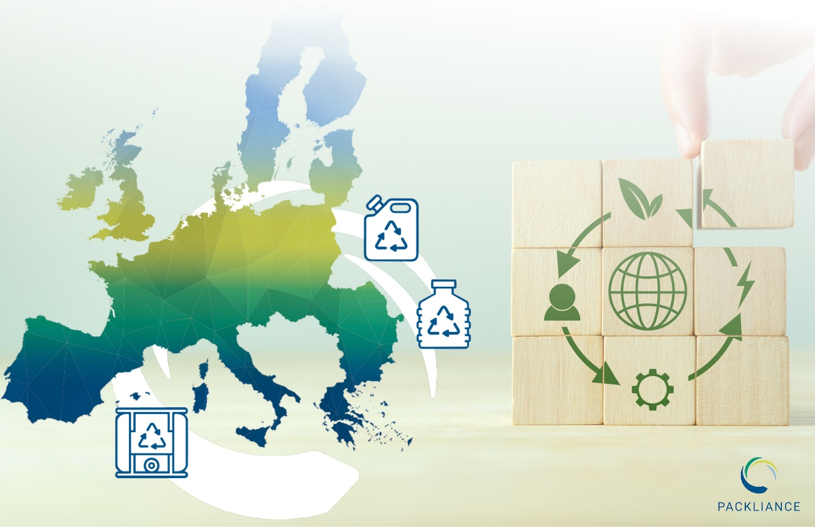
RIGK, GVÖ and KBS establish PACKLIANCE GmbH – Your Partner for Implementing the EU Packaging and Packaging Waste Regulation (PPWR)
The new company combines expertise and network competence to support industry and trade in meeting the requirements of Extended Producer Responsibility. © RIGK
Wiesbaden, November 2025 – The three producer-funded take-back systems, GVÖ Gebinde-Verwertungsgesellschaft der Mineralölwirtschaft mbH, Kreislaufsystem Blechverpackungen Stahl GmbH (KBS) and RIGK GmbH, have jointly founded PACKLIANCE GmbH, headquartered in Wiesbaden, Germany.
The new service company supports producers and manufacturers across the EU in ensuring legally compliant and practical implementation of the EU Packaging and Packaging Waste Regulation (PPWR). PACKLIANCE helps clients to understand, structure and implement complex requirements with a clear, solution-oriented approach – in line with its guiding principle: „Rules multiply. We simplify.“
“With PACKLIANCE, we created a dedicated partner to guide and support companies on their path towards PPWR conformity,” explains Jan Bauer, Managing Director of PACKLIANCE GmbH.
Integrated Consulting and Implementation Services
PACKLIANCE begins each engagement with a comprehensive assessment and develops gap and risk analyses in relation to PPWR requirements. The consulting approach is supported by digital tools and focuses on industrial and commercial packaging across all material types.
The service portfolio covers four key areas:
- Assessment – Role and obligation identification, gap analyses and workshops
- Compliance process support – Preparation of technical documentation, data platform management and communication with authorities
- EU-wide EPR compliance support – Consulting, registration and reporting of quantities to national systems
- Authorised representative services – For producers and manufacturers within the EU
A Proactive Approach in a Dynamic Regulatory Environment
Over the coming years, the PPWR will be further specified through numerous delegated acts and implementing measures. PACKLIANCE provides continuous support, keeping clients informed about regulatory developments in areas such as labelling requirements, recycled content, reuse targets, design-for-recycling guidelines, and verification procedures.
“The PPWR will fundamentally shape the packaging landscape in the coming years,” says Maria Hentze, Business Director of PACKLIANCE GmbH. “We help companies to prepare early for these new requirements and to design their processes to be both PPWR-compliant and efficient.”

About PACKLIANCE GmbH
PACKLIANCE GmbH is a joint service company founded by GVÖ, KBS and RIGK. It supports producers and manufacturers across the EU in implementing the PPWR, particularly in the areas of consulting, compliance assessment, EPR obligations and provision of authorised representatives. The company is headquartered in Wiesbaden, Hesse (Germany). The business activities of the founding companies remain unchanged.

Further Information:
PACKLIANCE GmbH  Jan Bauer, Managing Director  Maria Hentze, Business Director  Friedrichstr. 6  65185 Wiesbaden (Germany)  Phone: +49 (0) 6 11/ 73345901  info@packliance.eu; www.packliance.eu/en/ | Editorial Contact / Copies of Publications:  Konsens PR GmbH & Co. KG  Dr.-Ing. Jörg Wolters  Hans-Böckler-Straße 20  63811 Stockstadt (Germany)  Phone: +49 (0) 60 27/99005-13  mail@konsens.de; www.konsens.de
This press release and printable image material are available for download at: https://www.rigk.de/en/worth-knowing/press

