PRESS RELEASE
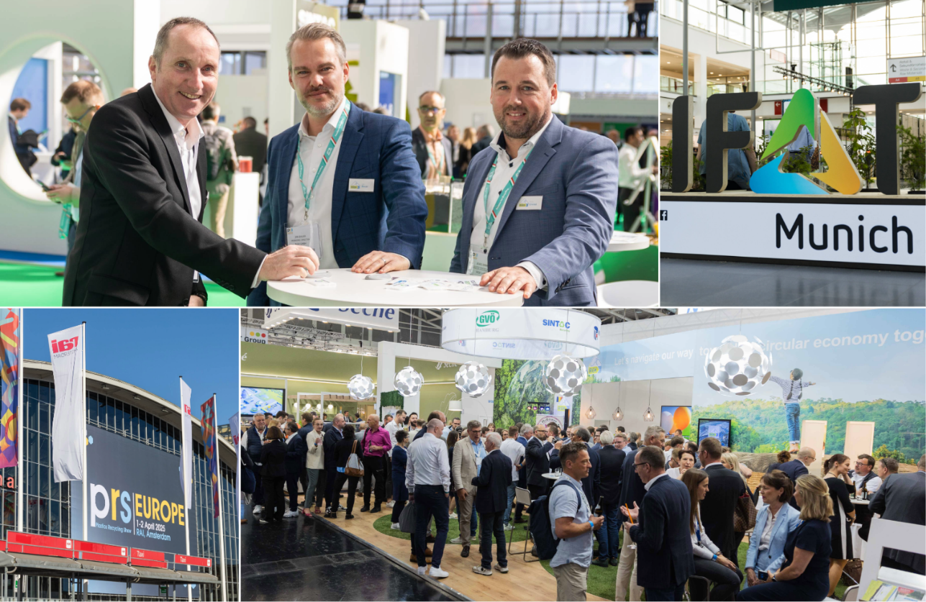
RIGK at IFAT and PRS Europe 2026: Network Showcases Solutions for Take-Back Systems, PPWR Implementation and Recyclate Quality
At the leading trade fairs IFAT and PRS Europe, RIGK showcases solutions to effectively advance the circular economy. © RIGK
Wiesbaden, March 2026 – At the two trade fairs running almost concurrently – IFAT (Munich, 4–7 May) and PRSE – Plastics Recycling Show Europe (Amsterdam, 5–6 May 2026) – RIGK will be presenting together with its network, which also includes plastship, Hannawald Plastik, PACKLIANCE and the DAkkS-accredited PlastCert unit. The focus will be on practical take-back systems as well as services relating to the Packaging and Packaging Waste Regulation (PPWR), Extended Producer Responsibility (EPR) and certification and material transparency as key foundations for reliable circular solutions, increased use of recyclates and commercially viable implementation in practice.
RIGK can be found at IFAT in Hall A6, Stand 316, and at PRSE at Stand B18. While IFAT focuses on environmental technologies, waste and resource management and the circular economy, PRSE centres on products and innovations in plastics recycling. Jan Bauer, Managing Director of RIGK, comments: “At both trade fairs we are taking the opportunity to demonstrate how short pathways between practice, regulation and the market can be established and sustained. On site, we will explain to visitors how take-back, recovery, compliance and quality assurance work as an integrated package – enabling the circular economy to be implemented not only in line with regulations, but also in a planned and economically viable manner.”

EPR solutions for take-back and recovery – across sectors
RIGK supports industry, commerce and agriculture with legally compliant and efficient take-back and recovery of packaging and plastics. The company will be presenting, among others, systems such as RIGK-SYSTEM, RIGK-G-SYSTEM and RIGK-PICKUP, as well as sector-specific solutions for agriculture, including PAMIRA, BEIZE, VerenA, ERDE and PRE-SERVICE.
Network covering the entire value chain
Together with Hannawald Plastik and plastship, RIGK complements its take-back systems with modules for operational implementation. These include sorting and processing of commercial plastic waste streams, transparent material management, and the marketing of recycled plastics. In addition, RIGK supports industrial and commercial customers with solutions for in-house waste management and material flow management.
PPWR: assessing requirements – structuring implementation
With EU requirements continuing to increase, practical implementability is moving further into focus. As a consulting company, PACKLIANCE supports businesses in implementing obligations arising from the PPWR.
PlastCert: Certification and material transparency
The PlastCert unit provides recognised certifications, including RecyClass Recycling Process and Recycled Plastic Traceability, as a basis for transparency across the supply chain and robust evidence.

Furter information:
RIGK GmbH  Jan Bauer (Managing Director)  Friedrichstr. 6  65185 Wiesbaden (Germany)  Phone: +49 (0) 6 11/ 30 86 00-56  bauer@rigk.de; http://www.rigk.de/en/ | Editorial enquiries, review copies:  Konsens PR GmbH & Co. KG  Dr.-Ing. Jörg Wolters  Hans-Böckler-Straße 20  63811 Stockstadt (Germany)  Phone: +49 (0) 60 27/99005-13  mail@konsens.de; www.konsens.de
You can download this press release as a DOC file, along with high-resolution images, from www.rigk.de/en/worth-knowing/press

