PRESS RELEASE
Berlin Packaging | Rixius and RIGK combine expertise in take-back, compliance and circular solutions for plastic packaging
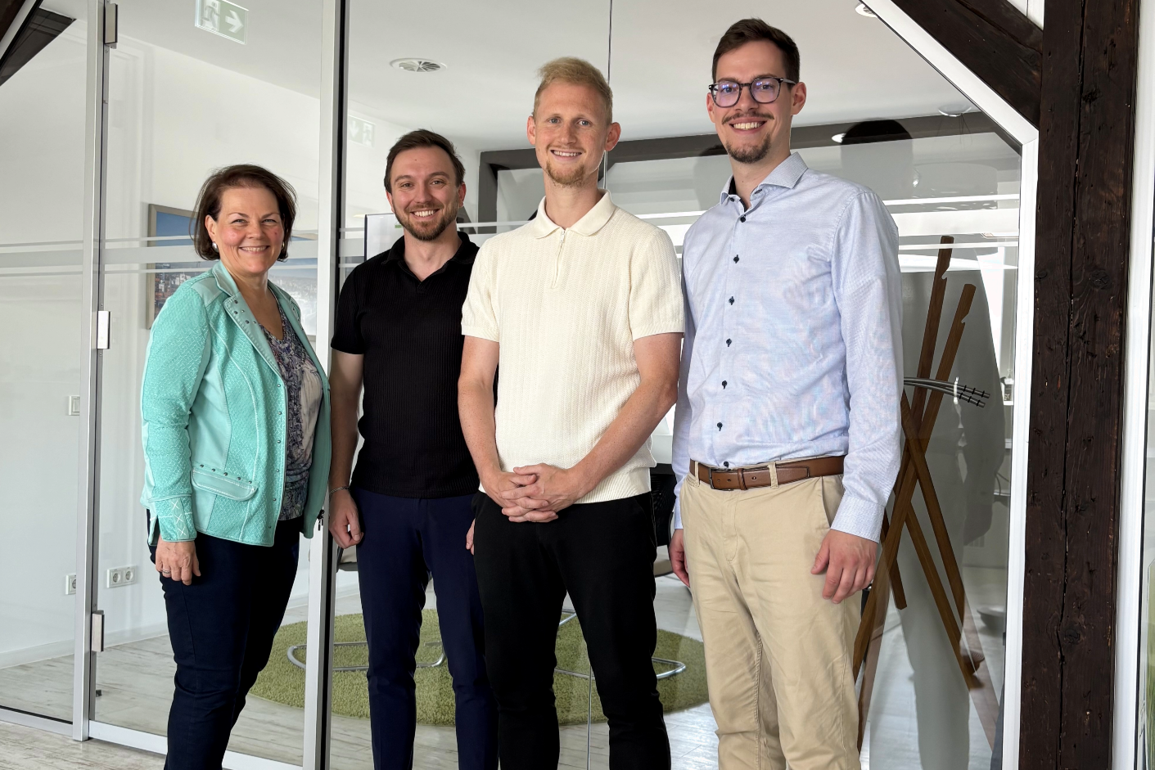
Wiesbaden/Mannheim, June 2026 – Berlin Packaging Rixius GmbH and RIGK GmbH are launching a strategic partnership to provide targeted support to companies in implementing take-back, recycling and regulatory compliance for plastic packaging. The collaboration centres on a joint approach designed to simplify the route from packaging application to verifiable recycling – with a view to the use of recyclates and closed-loop options.
Ingrid Krieger (RIGK) and Alexander Geiß (Berlin Packaging | Rixius), together with Yannik Hünerbein and Lukas Schneider, both RIGK, at the kick-off meeting for the joint project in Wiesbaden. © RIGK
Packaging users in industry and commerce are facing greater challenges than ever in aligning increasing requirements from packaging legislation, EU regulation and internal sustainability targets with their operational processes. The partnership between Berlin Packaging | Rixius and RIGK addresses precisely this point: it combines packaging expertise and customer proximity with know-how in take-back, recycling and compliance.
“Many companies want to return plastic packaging in a legally compliant way, document evidence properly and at the same time advance their circularity goals. This is exactly where we are working with Berlin Packaging | Rixius: we make take-back, compliance and circular solutions simpler, safer and verifiable,” explains Lukas Schneider, Business Development Manager at RIGK GmbH.
Two specialists bridge the gap between packaging procurement and take-back
The collaboration brings together two complementary strengths. Berlin Packaging | Rixius contributes extensive packaging expertise, application-focused consulting and close relationships with packaging users across a wide range of segments. RIGK complements this with many years of experience in take-back and recycling systems, regulatory expertise, established system structures, and the ability to provide evidence and reporting.
The result is a structured and practical route for returning plastic packaging to material cycles in a legally compliant manner. Companies receive support from the initial assessment and selection of suitable take-back options through to organisational implementation and transparent documentation.
Focus on compliance security, operational relief and measurable circular impact
The partnership is designed to support packaging users in three key areas in particular. Firstly, it strengthens compliance security by helping companies assess their obligations and documentation requirements – including in the context of the German Packaging Act (VerpackG), VerpackDG, PPWR, LUCID, and documentation and reporting obligations.
Secondly, it reduces operational effort, as take-back, recycling and organisational implementation are coordinated and supported by clear points of contact. Thirdly, it creates the basis for measurable circular impact: structured take-back and recycling can improve collection quality and circularity – with a view to the use of recyclates and closed-loop approaches.
“Our shared objective is to provide packaging users with straightforward access to legally compliant take-back and recycling. To achieve this, we are combining our expertise along the value chain – from packaging application through to a verifiable circular solution,” adds Alexander Geiß, Manager Business Excellence Logistics at Berlin Packaging | Rixius.
Structured entry through status check, consulting and implementation
At the start of the collaboration, the focus is on take-back and system integration. A structured compliance and status check serves as the entry point to determine each company’s individual starting position. This may include questions relating to registration, system connection, take-back organisation, evidence management and potential areas for optimisation.
Building on this, Berlin Packaging | Rixius and RIGK support the next steps – from technical assessment and the selection of suitable take-back solutions through to implementation, including reporting and evidence management. For suitable applications, a take-back option in the Mannheim area is available at the start of the cooperation. In addition, nationwide solutions can also be reviewed and implemented for larger projects.
Outlook: From take-back to the further development of circular solutions
While the short-term focus is on the efficient and legally compliant take-back of plastic packaging, the partnership is aimed in the medium term at further developing the use of recyclates and closed-loop options for suitable applications. In this way, the cooperation is intended to make a further contribution to a robust, transparent and verifiable circular economy for plastic packaging.

About Berlin Packaging | Rixius
Berlin Packaging | Rixius is part of the Berlin Packaging Group, the world’s largest Hybrid Packaging Supplier®. The company supports customers with packaging solutions and application-focused consulting in the Industrial, Healthcare, Personal Care & Beauty, and Food & Beverage segments.
About RIGK
RIGK GmbH stands for sustainable and efficient solutions – providing tailored take-back and resource-saving recycling of packaging and plastics in line with the relevant legal frameworks. Founded more than 30 years ago by industry for industry, agriculture and trade, RIGK is now active worldwide in the fields of Extended Producer Responsibility (EPR), climate protection and the circular economy.

Further information:
RIGK GmbH  Lukas Schneider  Business Development Manager  Friedrichstr. 6  65185 Wiesbaden (Germany)  Phone: +49 (0) 151 40706053  lschneider@rigk.de; www.rigk.de/en/  Berlin Packaging Rixius GmbH  Alexander Geiß  Manager Business Excellence Logistics  Otto-Hahn-Straße 19  68169 Mannheim (Germany)  Tel.: +49 (0) 173 69774  alexander.geiss@berlinpackaging.com; www.rixius.com/en/ | Redaktioneller Kontakt, Belegexemplare:  Konsens PR GmbH & Co. KG  Dr.-Ing. Jörg Wolters  Hans-Böckler-Straße 20  63811 Stockstadt (Germany)  Phone: +49 6027/99005-13  mail@konsens.de; www.konsens.de
You can download this press release as a DOC file, along with the image in print-ready resolution, from www.rigk.de/en/worth-knowing/press

