PRESS RELEASE
ERDE Switzerland Reports Remarkable Collection Results: Over 2,200 Tons of Agricultural Plastics in 2023
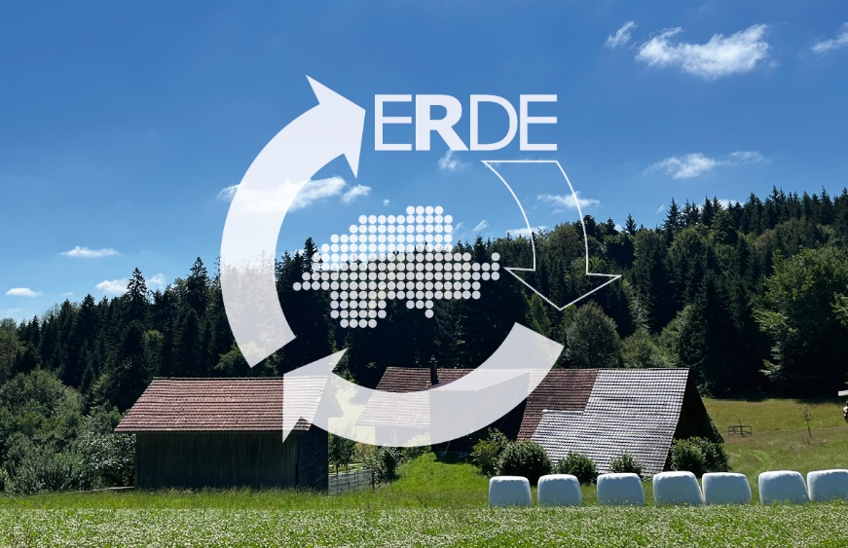
Wiesbaden/Aarau, March 2024 – An official audit report has confirmed that ERDE Switzerland collected a total of over 2,200 tons of agricultural plastics in the year 2023. This figure marks a remarkable increase compared to the previous year 2022, during which 1,800 tons of plastics were retrieved.
ERDE Switzerland concludes its second year as a take-back system for agricultural plastics in Switzerland with impressive achievements. © ERDE Switzerland
Silage stretch films, silage flat films, underlay films, and round bale nets are just some of the plastic products used in agriculture annually in large quantities, offering significant benefits during the harvest season. Despite their advantages, improperly collected agricultural plastics can burden the environment. Therefore, manufacturers of agricultural plastics take responsibility for taking back and recycling as many of their products as possible. In Germany, the IK-initiative ERDE has established itself as the system for the collection and recycling of harvest plastics for over a decade. With the introduction of ERDE Switzerland in 2022, a voluntary take-back system was launched under the umbrella of KUNSTSTOFF.swiss, with RIGK as the system operator and in collaboration with other members from Switzerland for the Swiss agricultural sector. The aim is to keep valuable resources in circulation even in neighboring countries and reduce CO2 emissions through joint efforts.
In the past second collection year, ERDE Switzerland has already collected approximately 2,200 tons of agricultural plastics and recycled the silo and stretch films. Additionally, more collection points have been gained, and today, 116 collection points participate by collecting used harvest plastics. Kurt Röschli, President of ERDE Switzerland, is pleased: "400 tons more than last year, that's quite an achievement! The increase shows the growing interest and increased participation in ERDE Switzerland." Starting this year, baling twines will also be taken back, and the collection point network will be continuously expanded. If the nearest collection point is far away, there is the possibility to open a collection point oneself (temporarily or permanently), so that farms in the vicinity benefit from a shorter distance. Agricultural businesses can take proactive steps and express interest by contacting info@erde-schweiz.ch.
The used films are recycled in Switzerland and other certified recycling facilities in the EU. The process of collection and recycling is confirmed by an independent auditor who creates a report certifying the recovery. Through the collaboration of all stakeholders at ERDE Switzerland, the material cycle is closed, resources are conserved, and the environment is protected.
With between 6,000 to 7,000 tons of agricultural plastics generated annually in Switzerland, the potential for recycling remains enormous. It demonstrates the importance of continuing to collect and recycle used agricultural plastics carefully.

About ERDE Switzerland
An estimated 6,000 tonnes of agricultural plastics are used annually in Switzerland. In order to reduce the entry of plastics from the agricultural sector into the environment and to promote recycling, KUNSTSTOFF.swiss (the association of the Swiss plastics industry), members of the German ERDE Initiative, RIGK as system operator and other supporters from Switzerland founded the independent association ERDE Switzerland on 14 July 2021. The system has been operational since 1 January last year, and since the official start of collections in April 2022, agricultural plastics in Switzerland can be dropped off at collection points and sent for recycling. More information about ERDE Switzerland can be found here.

Contact: ERDE Switzerland:  c/o KUNSTSTOFF.swiss  Kurt Röschli, Managing Director  Verena Jucker, Head of Communication  Schachenallee 29C, CH-5000 Aarau (Switzerland)  Phone: +41 62 834 00 60  info@erde-schweiz.ch;  https://kunststoff.swiss | More information ERDE Germany:  RIGK GmbH  Boris Emmel  System Manager ERDE  Friedrichstr. 6, D-65185 Wiesbaden (Germany)  Tel.: +49 611 308600-20  emmel@rigk.de;  www.erde-recycling.de/en/
You can access this press release as a doc file, along with high-resolution images for download, at www.rigk.de/wissenswert/presse/en/.

