**Press Release**

RIGK Closes Recycling Loop for Plastics: Acquisition of Hannawald Plastik GmbH

*Wiesbaden, November 2023 -* RIGK GmbH has successfully completed the acquisition of Hannawald Plastik GmbH, located in Bingen am Rhein. Previously, this company specialized in the sorting and refining of packaging materials made of PE (polyethylene) and PP (polypropylene) and had been a proven waste disposal service provider for RIGK over many years. With this move, RIGK reinforces its ongoing commitment to sustainable plastic circulation and resource conservation.

With the acquisition of Hannawald and the impending retirement of Albrecht Keiper, who co-founded and significantly shaped the company, and had been leading it together with Harald Sauer, a reorganization of the management level is taking place. As of now, Harald Sauer, a member of Hannawald's management since 2012, and Jan Bauer, General Manager of RIGK, jointly lead the company. RIGK expresses its gratitude to Mr. Keiper for his valuable contribution to the successful development of Hannawald Plastik GmbH and wishes him all the best in retirement.

Ein Bild, das Person, Kleidung, Lächeln, draußen enthält.

***Jan Bauer and Harald Sauer, the new management of Hannawald Plastik GmbH, on-site at the company's premises in Bingen am Rhein. © RIGK***

In 2023, RIGK had already established the PlastCert department, specializing in the certification of recyclability, recycled content, and recycling processes, as well as the inspection of plastic recyclates with individual consulting. In addition to the establishment of plastship, a subsidiary founded in 2018 as a digital marketplace for plastic recyclates, RIGK now enhances its involvement in all phases of the recycling loop with the acquisition of Hannawald Plastik GmbH.

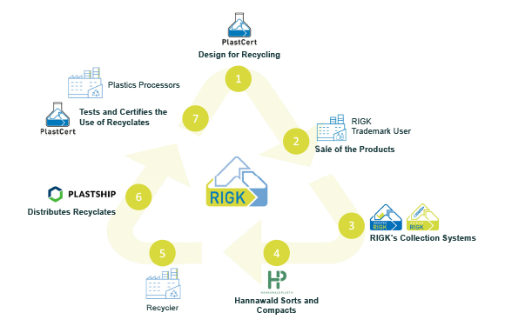

***The presence throughout the entire value chain of plastic recycling, from packaging licensing to the collection and recycling of raw materials to the trade of recyclates, is another step towards a more circular economy.***

Regarding this, Bauer stated, "Hannawald's in-depth expertise and years of experience in sorting and refining packaging materials enable us to further enhance the quality of raw materials taken back through RIGK and processed into recyclates for new plastic products. The partnership allows for the tailored production of recyclates, which can be customized to the specific requirements of end products from the early stages of collecting, sorting, and refining plastic products. This contributes overall to a more efficient and high-quality recycling process."

For more information about Hannawald Plastik GmbH, please visit [here](https://hannawaldplastikgmbh.de/Home).

**About RIGK:**

Established in 1992, RIGK GmbH operates as a certified specialized company in the field of collection systems for the return and recycling of industrial and commercial packaging materials and plastics. The company organises the recovery of used, empty packaging and plastics and arranges their safe and sustainable recycling. Moreover, RIGK provides advices on the development of individual recycling and recovery solutions on both national and international levels. Internationally, RIGK also maintains a presence in Romania through RIGK Romania (<http://rigk.ro/>), where it similarly recovers and recycles used packaging and plastics. Since the year 2023, RIGK has expanded its offerings through the [PlastCert](https://www.rigk.de/en/about-rigk/plastcert-consulting-certification) division, providing certifications for recyclability and recycled content, as well as material testing and individualized consultation for recyclates. With these initiatives, the company from Wiesbaden advances and reinforces the principles of circular economy by promoting recycling and sustainable utilization of plastics and packaging. RIGK GmbH's shareholders consist of well-known manufacturers within the plastics and packaging industry. Since 2006, RIGK GmbH has been a member of [EPRO](https://www.epro-plasticsrecycling.org/) and has founded the working group dedicated to the recycling of agricultural plastic waste. Additionally, RIGK hosts the [International Recycling Forum](https://www.rigk.de/en/sustainability/international-recycling-forum) in Wiesbaden and is a shareholder of plastship (<www.plastship.com>), the operator of an online platform aimed at accessing new markets and serving as a distributor for recycled plastics.

**About Hannawald:**

Since 1984, Hannawald Plastik GmbH has specialized in the recycling of PE and PP packaging materials, particularly the sorting of commercial films. The company also trades in recycled plastics and accepts bales and loose materials at its warehouse in Bingen am Rhein. In 2023, the company was acquired by RIGK GmbH and, together with it, advocates for sustainable solutions in the plastic sector.

|  |  |
| --- | --- |
| Contact RIGK / Hannawald:  Harald Sauer  General Manager Hannawald Plastik GmbH  +49 6721 10334  [hannawaldplastikgmbh(at)t-online.de](mailto:hannawaldplastikgmbh@t-online.de)  Jan Bauer  General Manager RIGK GmbH / Hannawald Plastik GmbH  +49 611 308600-16  [bauer(at)rigk.de](mailto:bauer@rigk.de) | Editorial contact, specimen copies:  Konsens PR GmbH & Co. KG  Dr.-Ing. Jörg Wolters Hans-Böckler-Straße 20  D-63811 Stockstadt am Main  Tel.: +49 (0) 60 27 99005-13  [mail@konsens.de](mailto:mail@konsens.de); www.konsens.de |

You can download this press release as a docx file and the images in printable resolution at www.rigk.de/wissenswert/presse/en