PRESS RELEASE
The ERDE Initiative is participating in the “Waste Separation Works” campaign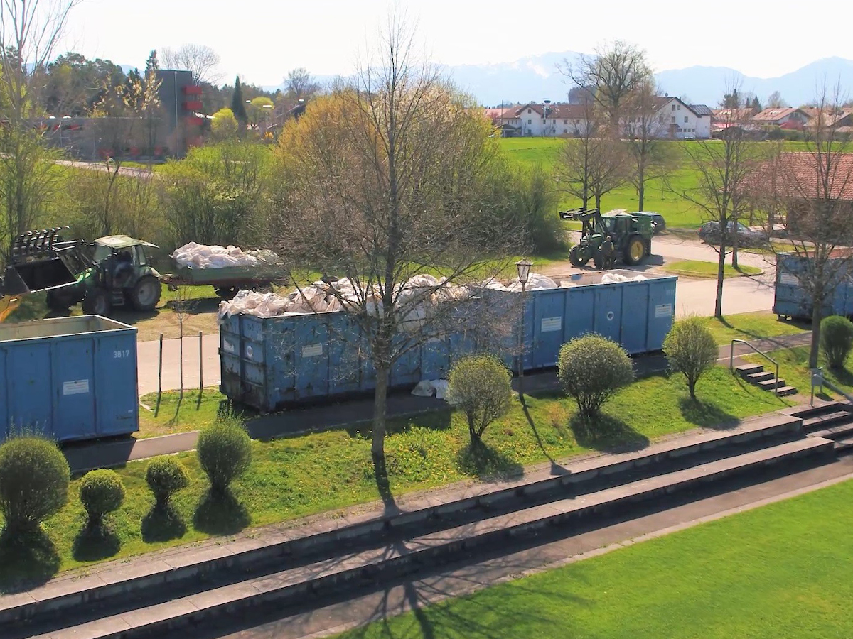
Separate collection of crop plastics at ERDE collection points throughout Germany. © ERDE
Bad Homburg, März 2023
The ERDE Initiative is cooperating with the “Mülltrennung wirkt” (Waste Separation Works) campaign, which is a an initiative of the dual systems for packaging that promotes better waste separation and waste prevention in Germany. The campaign aims to raise awareness among the population regarding correct collection and sorting behaviour and thus contribute to environmental protection. Correct waste separation can facilitate the recycling of waste and thus improve recycling output and conserve resources. It is particularly important to properly sort packaging that is collected either via the yellow bin / yellow sack collection containers or via glass and paper containers to ensure that their valuable raw materials are kept in the cycle.
The ERDE Initiative is participating in this campaign in order to draw attention to the environmentally friendly takeback of agricultural plastics. This is because unlike household packaging, used crop plastics cannot be dropped off of via the dual systems. They disrupt sorting processes here and prevent recycling. ERDE offers a nationwide recovery and recycling infrastructure for this purpose. The used agricultural plastics are collected via a network of collection points or by direct collection, and are then professionally recycled.
“We are pleased to be working with the ‘Waste Separation Works’ campaign to raise awareness of the environmentally friendly return and recovery of used agricultural plastics”, says Boris Emmel, System Manager ERDE. “Correct separation is important for the environment and subsequent recycling steps. We cooperate closely with the agricultural sector, which has shown a high degree of willingness to separate collections and returns in the past.”

About ERDE
Under the umbrella of IK Industrievereinigung Kunststoffverpackungen e.V. and in cooperation with system operator RIGK, ERDE organises the recovery and recycling of used crop plastics, such as silage film, stretch film, asparagus film, perforated film, bale nets, baler twine and PP non-wovens, through collection partners throughout Germany. Supply agencies and farmers collect the crop plastics, pack and deliver them – swept clean and free of the worst of the dirt – to a collection point (www.erde-recycling.de/rund-um-die-abgabe/sammelstellen-termine.html). Collection points set the collection prices individually. Recycling companies process the collected goods into new plastic feedstocks.
Any producer or distributor of crop plastics that supplies the German market can become an ERDE member. The following 25 ERDE members take responsibility for their products and the environment: ape Europe, ASPLA S.A., Groupe Barbier, Berry bpi, Berry Fiberweb France, CLAAS Vertriebsgesellschaft mbH, Cordex - Companhia Industrial Textil S.A., Coveris Flexibles Austria GmbH, Daios Plastics S.A., DUOPLAST AG, KARATZIS S.A., Manupackaging Deutschland GmbH, NOVATEX, PIIppo OYJ, Plastika Kritis S.A., POLIFILM Extrusion GmbH, Ab Rani Plast Oy, Reyenvas S.A., RKW Agri GmbH & Co. KG, Sicor - Sociedade Industrial de Cordoaria S.A., Solplast S.A., Sotrafa S.A., Tama Group, Tecfil S.A., Tencate Geosynthetics, TRIOWORLD GmbH und WKI Tegafol Sp. z o.o-

Further information:

Initiative ERDE
IK Industrievereinigung Kunststoffverpackungen e.V.
Dr. Lorena Managing Director ERDE
Kaiser-Friedrich-Promenade 43
61348 Bad Homburg
l.fricke(at)erde-recycling.de;
Phone: +49 (0) 6172 92 66 30

