PRESS RELEASE
ERDE Presents Positive Review after Agritechnica 2023
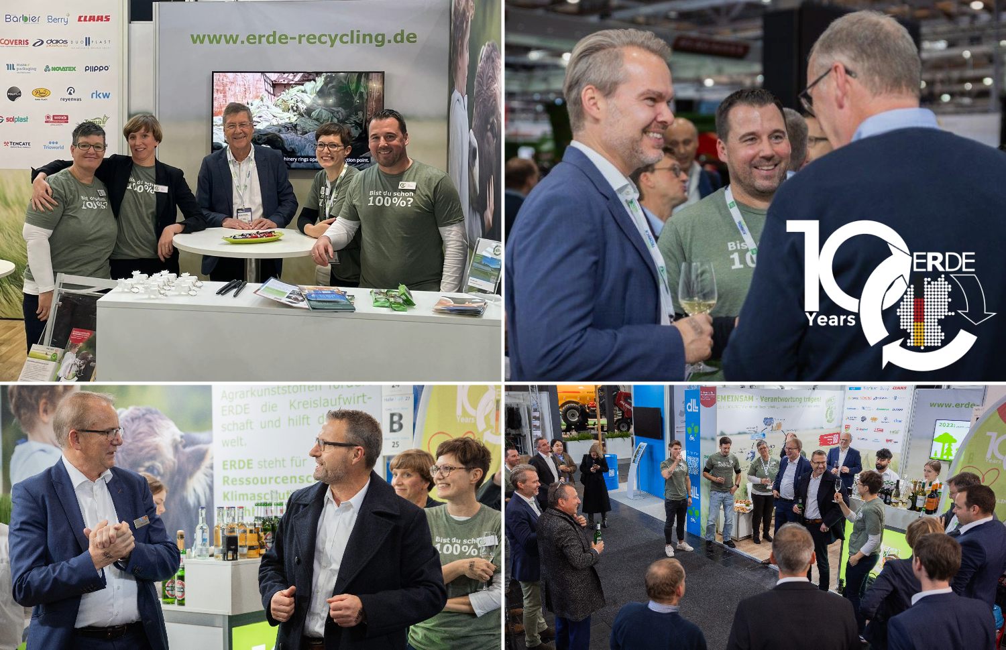
Wiesbaden/Bad Homburg, November 2023 - the world's leading trade fair for agricultural machinery, achieved a record result with 2,812 exhibitors from 52 countries and over 470,000 visitors from 149 countries. In addition to showcasing impressive technological innovations in agriculture, the fair also marked the 10th anniversary of the IK (Industrievereinigung Kunststoffverpackungen e.V.) initiative ERDE.
The ERDE team alongside committed partners at the initiative's booth at Agritechnica. © RIGK

Since its founding in 2013, ERDE has made significant progress in promoting the circular economy for agricultural plastics. At Agritechnica, the initiative proudly presented last year's success: Over 68 percent of silo and stretch films were collected and recycled. With the support of 25 manufacturers of agricultural plastics and agricultural enterprises, ERDE collected and recycled a total of over 38,000 tons of used agricultural films, nets, yarns, and nonwovens, achieving a recycling rate of over 95 percent.
With this outcome, ERDE reached its current peak of development: "We had an outstanding fair, characterized by a dedicated team, stimulating conversations, and the delightful encounter with numerous partners and farmers. They all show great motivation to return their agricultural plastics through ERDE and ensure they are recycled," emphasized Dr. Lorena Fricke, Managing Director of ERDE.

The fair was a resounding success, as confirmed by ERDE board members Franz-Josef Lichte and Ewald Werschmann during their speech at a get-together at the ERDE booth for the 10th anniversary of the initiative.The celebration provided an opportunity to reflect on the successes of the past decade. In his speech, Werschmann emphasized the excellent collaboration, while Lichte briefly summarized the impressive development of ERDE over the last 10 years: "ERDE's success story is as impressive in numbers as it is in significance. From about 2,000 tons of collected agricultural plastics in 2014, we are proud to have recorded nearly 40,000 tons in 2022. Since its founding in 2013, ERDE has collected over 150,000 tons of used crop plastics. This development underscores the efficiency of our efforts in the circular economy. We are committed to continuing this positive trend in the future to promote sustainable management of agricultural plastics."
ERDE System Manager Boris Emmel also looks ahead after Agritechnica: "The progress achieved is not only gratifying but also a commitment. We want to harness the energy and very positive feedback from the fair to achieve the ambitious goals for the coming years."
The ERDE team thanks all visitors, partners, and friends for a successful Agritechnica 2023 and looks forward to an equally successful future.
About ERDE
Under the umbrella of the IK Industrievereinigung Kunststoffverpackungen e.V. and in cooperation with RIGK as system operator, ERDE organises the separate return and recycling of used crop plastics such as silage film, stretch film, asparagus film, perforated film, mulch film, non-wovens, bale nets and baler twine via collection partners throughout Germany. Contractors and farmers collect the crop plastics and hand them in bundled - broom-clean and freed of coarse dirt - at a collection point. The return fee is set directly by the collection point. Recycling companies then process the collected material into new plastic raw materials.
More information on members, 100% distribution partners and participating brands can be found here.
Any manufacturer or primary distributor of crop plastics who supplies the German market can become a member of ERDE. The following 27 companies assume responsibility for their products and the environment as ERDE members: ape Europe, ASPLA S.A., Groupe Barbier, Berry bpi, Berry Fiberweb France, CLAAS Vertriebsgesellschaft mbH, Cordex - Companhia Industrial Textil S.A., Coveris Flexibles Austria GmbH, Daios Plastics S.A., DUOPLAST AG, KARATZIS S.A., Manupackaging Deutschland GmbH, NOVATEX, PIIppo OYJ, Plastika Kritis S.A., POLIFILM Extrusion GmbH, Ab Rani Plast Oy, Reyenvas S.A., RKW Agri GmbH & Co. KG, Sicor - Sociedade Industrial de Cordoaria S.A., Solplast S.A., Sotrafa S.A., Tama Group, Tecfil S.A., Tencate Geosynthetics, TRIOWORLD GmbH and WKI Tegafol Sp. z o.o and XES GmbH.
Further information:
ERDE initiative / IK Industrievereinigung Kunststoffverpackungen e.V.
Dr. Lorena Fricke, Managing Director ERDE
Kaiser-Friedrich-Promenade 43
61348 Bad Homburg
Phone: +49 (0) 6172 92 66 30

