PRESS RELEASE
Free takeback of empty used Big Bags from the agricultural sector
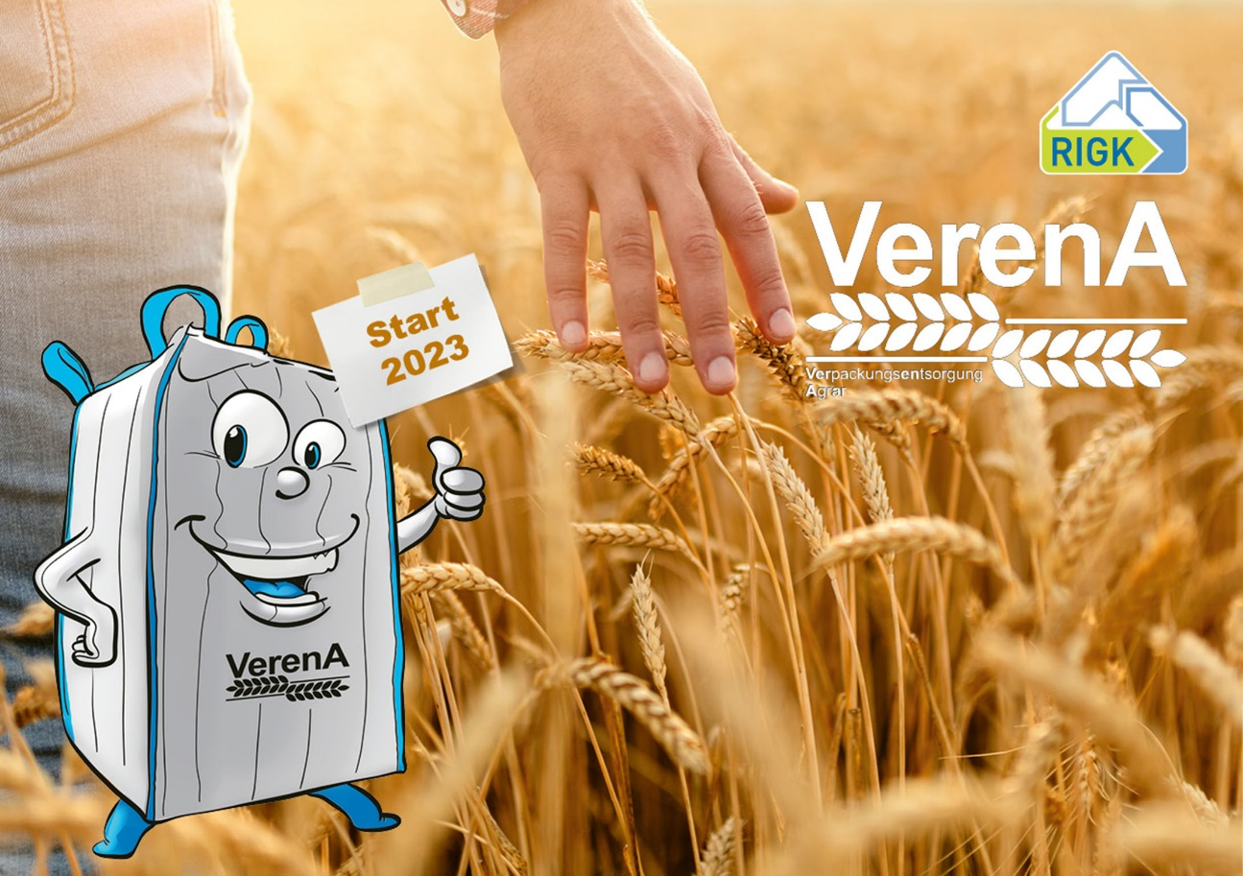VerenA is the new system organised by RIGK and industry associations for the recovery of Big Bags from the agricultural sector © RIGK
Wiesbaden, March 2023 – VerenA (Packaging Recovery for Agriculture -Verpackungsentsorgung Agrar) is a new system organised by RIGK and German agricultural industry associations for the environmentally friendly recovery and recycling of used FIBCs (Big Bags) from the agricultural sector. Within the framework of this system final consumers can hand in such packaging and related secondary and transport packaging free of charge. The main requirement here is that the Big Bags have been previously filled with non-hazardous products such as seeds or fertilisers and that all the packaging materials are licensed in VerenA and bear the trademark.
Following the launch of the system in spring 2023, plans call for up to 400 collection points nationwide to offer collection dates that are published on the VerenA website www.verena-recycling.de. To ensure that the collection campaigns run smoothly, the Big Bags must be clearly marked with the VerenA trademark, empty of residues, free of trickles and clean on the outside. The bags can be dropped off either rolled up and bound together or else packed in a single Big Bag.
Along with RIGK as the system operator, DER AGRARHANDEL - Bundesverband Agrarhandel and Verein der Getreidehändler der Hamburger Börse e.V. (German Agricultural Trade Association and the Grain Traders’ Association of the Hamburg Stock Exchange), the Bundesverband Deutscher Pflanzenzüchter e. V. (German Plant Breeders' Association – BDP), the Bundesverband der VO-Firmen e.V. (German Association of Seed Propagation Organisations – BVO) and the Deutsche Raiffeisenverband e.V. (German Federation of Rural Cooperatives – DRV) also participate in VerenA. Together with RIGK, the associations form the “Interessengemeinschaft (IG) VerenA” (VerenA Interest Group).
Contribution to resource efficiency and environmental protection
By participating, packers/fillers and distributors fulfil their recovery and recycling obligations as defined in article 15 of the German Packaging Act (VerpackG). The VerenA trademark confirms that their Big Bags can be dropped off at the official collection points. RIGK then ensures that the collected Big Bags are recycled by undergoing various processing stages in order to create high quality recyclate and manufacture new products thus completing the raw material cycle. Thus, with the new VerenA-SYSTEM, RIGK is making a further contribution to safe and legally compliant recycling of used packaging.
“By joining the VerenA-SYSTEM, packers/fillers and distributors of agricultural products in Big Bags show that they are legally compliant and responsible and contribute to resource efficiency and environmental protection”, says Jens Dambeck, System Manager of the VerenA-SYSTEM.
More collection points wanted
“With the collection of emptied Big Bags, we are meeting a need frequently expressed to us by our customers from agriculture and the agricultural industry”, Mr. Dambeck explains. “In doing so, we collect the materials where the sector is located – in the agricultural regions and with the help of partners in the agricultural field. In order to achieve the high system efficiency that we seek, we are looking for further agricultural trade businesses throughout Germany to act as collection points for the system. As VerenA partners, these businesses will offer short and easy ways for the final consumers to return their empty used packaging. At the same time, they will contribute to even more sustainability in agriculture in line with the principle of the circular economy.” We look forward to hearing from you via e-mail at verena-recycling(at)rigk.de or on the phone: +49 800 3086005.
Completes proven disposal systems for agriculture
VerenA is the latest addition to RIGK’s range of recovery systems for agriculture, which are grouped under the RIGK Agrar label. This also includes ERDE Recycling for the return of used plastics, the PAMIRA-SYSTEM for the takeback of plant protection product and liquid fertiliser packaging, PAMIRA-BEIZE for the return of seed dressing packaging and the PRE SYSTEM for the safe return of pesticides and other chemicals that have become unusable.

About RIGK
As a certified specialist for the operation of collection systems for the recovery and recycling of industrial and commercial packaging and plastics, RIGK GmbH, founded in 1992, organises the recovery of used, empty packaging and plastics and ensures their safe and sustainable recycling. Apart from that, the company provides consulting services in the development of customised reuse and recycling solutions. Internationally, RIGK is represented in Romania (www.rigk.ro), where it also deals with the recovery and recycling of used packaging and plastics. The shareholders of RIGK GmbH are well-known producers of plastics and packaging. Since 2006, RIGK GmbH has been a member of EPRO, where it also founded the working group for the recycling of agricultural plastic waste. RIGK also hosts the International Recycling Forum in Wiesbaden. The Wiesbaden-based RIGK company is a shareholder of plastship (www.plastship.com), which operates the online platform for tapping new markets for recycled plastic.
Further informationen:  RIGK GmbH  Claudia Hoese  Friedrichstr. 6  D-65185 Wiesbaden  Phone: +49 (0) 6 11/ 30 86 00-12  hoese(at)rigk.de; www.rigk.de/en/ | Editorial contact, specimen copies:  Konsens PR GmbH & Co. KG  Dr.-Ing. Jörg Wolters  Im Kühlen Grund 10  D-64823 Groß-Umstadt  Phone: +49 (0) 60 78/93 63-13  mail(at)konsens.de; www.konsens.de/en/
You can find this press release as a docx file as well as the pictures in printable resolution for download at www.rigk.de/wissenswert/presse

